Chapter 4H
machine description

Pull Roll
The Pull Roll maintains a stable tension from one unit to another along the NAIB Line 5 machine.
Contents
About the Pull Roll 4H-3
Parts of the Pull Roll 4H-4
Idler Rolls 4H-4
Driving Rolls 4H-4
Pressure Nip Roll 4H-4
Load Cell 4H-4
Drive Motors 4H-5
Operation of the Pull Roll 4H-5
Pressure and Tensioning 4H-5
Tension and Alignment Monitor 4H-6
Air Pressure Regulator 4H-6

Figures
Figure 4H-1. Pull Roll Drawing 4H-3
Figure 4H-2. Pull Roll Drive Motor 4H-5
Figure 4H-3. Tension and Alignment Monitor 4H-6
Figure 4H-4. Air Pressure Regulator 4H-6
Figure 4H-5. Load Cell 4H-6

About the Pull Roll
The Pull roll maintains a constant tension to stabilize the web.
The Pull roll is to maintain a set speed and also to ensure an even stable tension on the moving web both through its rollers and laterally across the width of the web, while ensuring that the web is not stretched out of shape.
The Pull roll alleviates when there are variations in the web thickness or abnormal tension shock from other units and keep the web taut.
There are many reasons why the web might not be stable as it moves through the line like variations in the web thickness. The Pull roll alleviate these problems and keep the web taut.
The Pull roll drives can operate under tension or draw feed. Tension mode runs on a specific line tension; draw mode runs as a percentage faster or slower than the line speed. Tension mode is set in kg/cm2. Electrical force transducers (load cells) monitor the actual tension on the web and moderate the speed of the drive to maintain the tension setpoint.

The Pull roll follows after the Perforator. This unit, in its sum, ensures that the web is aligned, properly tensioned, and moving at the proper speed.
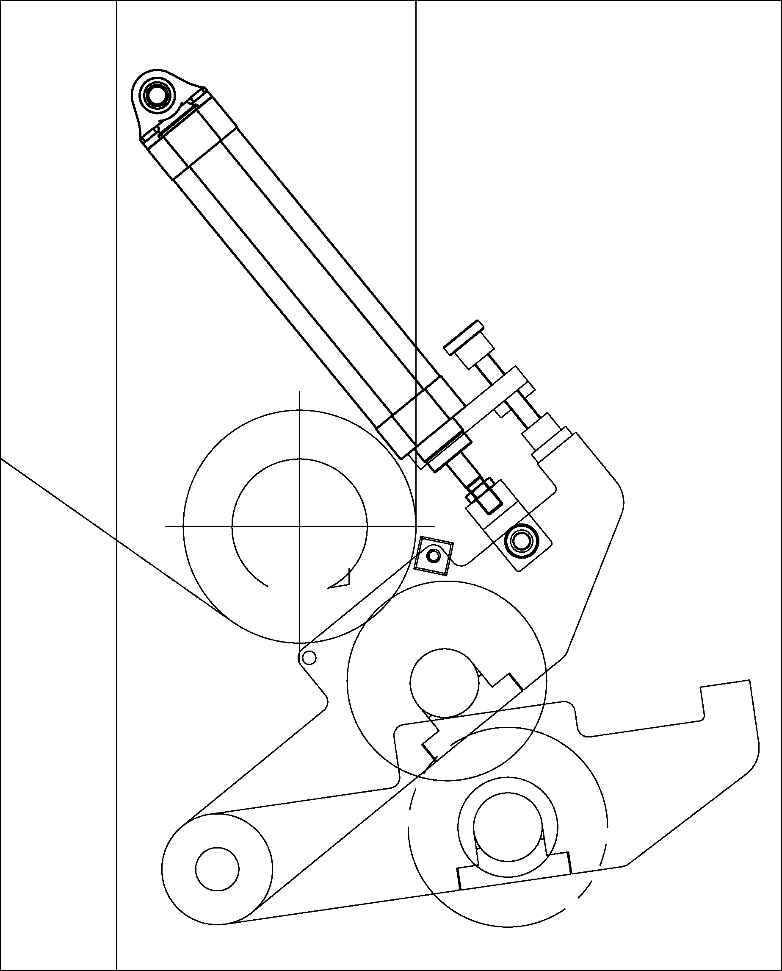
Rubber roll
Steel roll
Figure 4H-1. Pull Roll Drawing

Parts of the Pull Roll
The Pull roll consists mainly of idler rolls, driver rolls, a nip roll, a pressure monitor, a load cell, and a drive motor.

Idler Rolls
Each Pull roll stand includes lead-in and lead-out idler rolls. These idler rolls provide the proper web path for consistent wrap around the driving rolls. The lead-out idler rolls are tensioned — mounted with a load cell.

Driving Rolls
The Pull roll consists of one fixed-position, 210-mm diameter, chromium plated driving roll.

Pressure Nip Roll
Pull roll has a pressure nip roll covered by a rubber(NBR—nitrile butadiene rubber—Hs 72°±3°) conductive material with pivot mounting and pneumatic actuation.
A tension piston regulates the pressure that the nip roll applies to the top driving roll. The pressure from air cylinder pistons opens, closes, and loads the nip. Flow control valves (located at the cylinders) set the open and close speed. The nip is operated from the corresponding Pull roll operation stations.
The Pull roll nip on (closed) when the machine is on or driving, and nip off when the machine stops. Depending on the properties of the substrate or our production requirements, tension isolation can be established with the nip open or closed.

Load Cell
A load cell mounted on the Pull roll’s lead-out idler roll monitors web tension. It indicates the actual tension of the web so that it can be better regulated.

Drive Motors
The drive rolls on Pull roll is belt-driven by AC vector motors. The 5.5 kW AC vector helical geared drive motor attached to a gear reducer and a Timing belt powers the drive rolls. The motor operates under tension or draw regulate the speed of the web through the Pull roll.
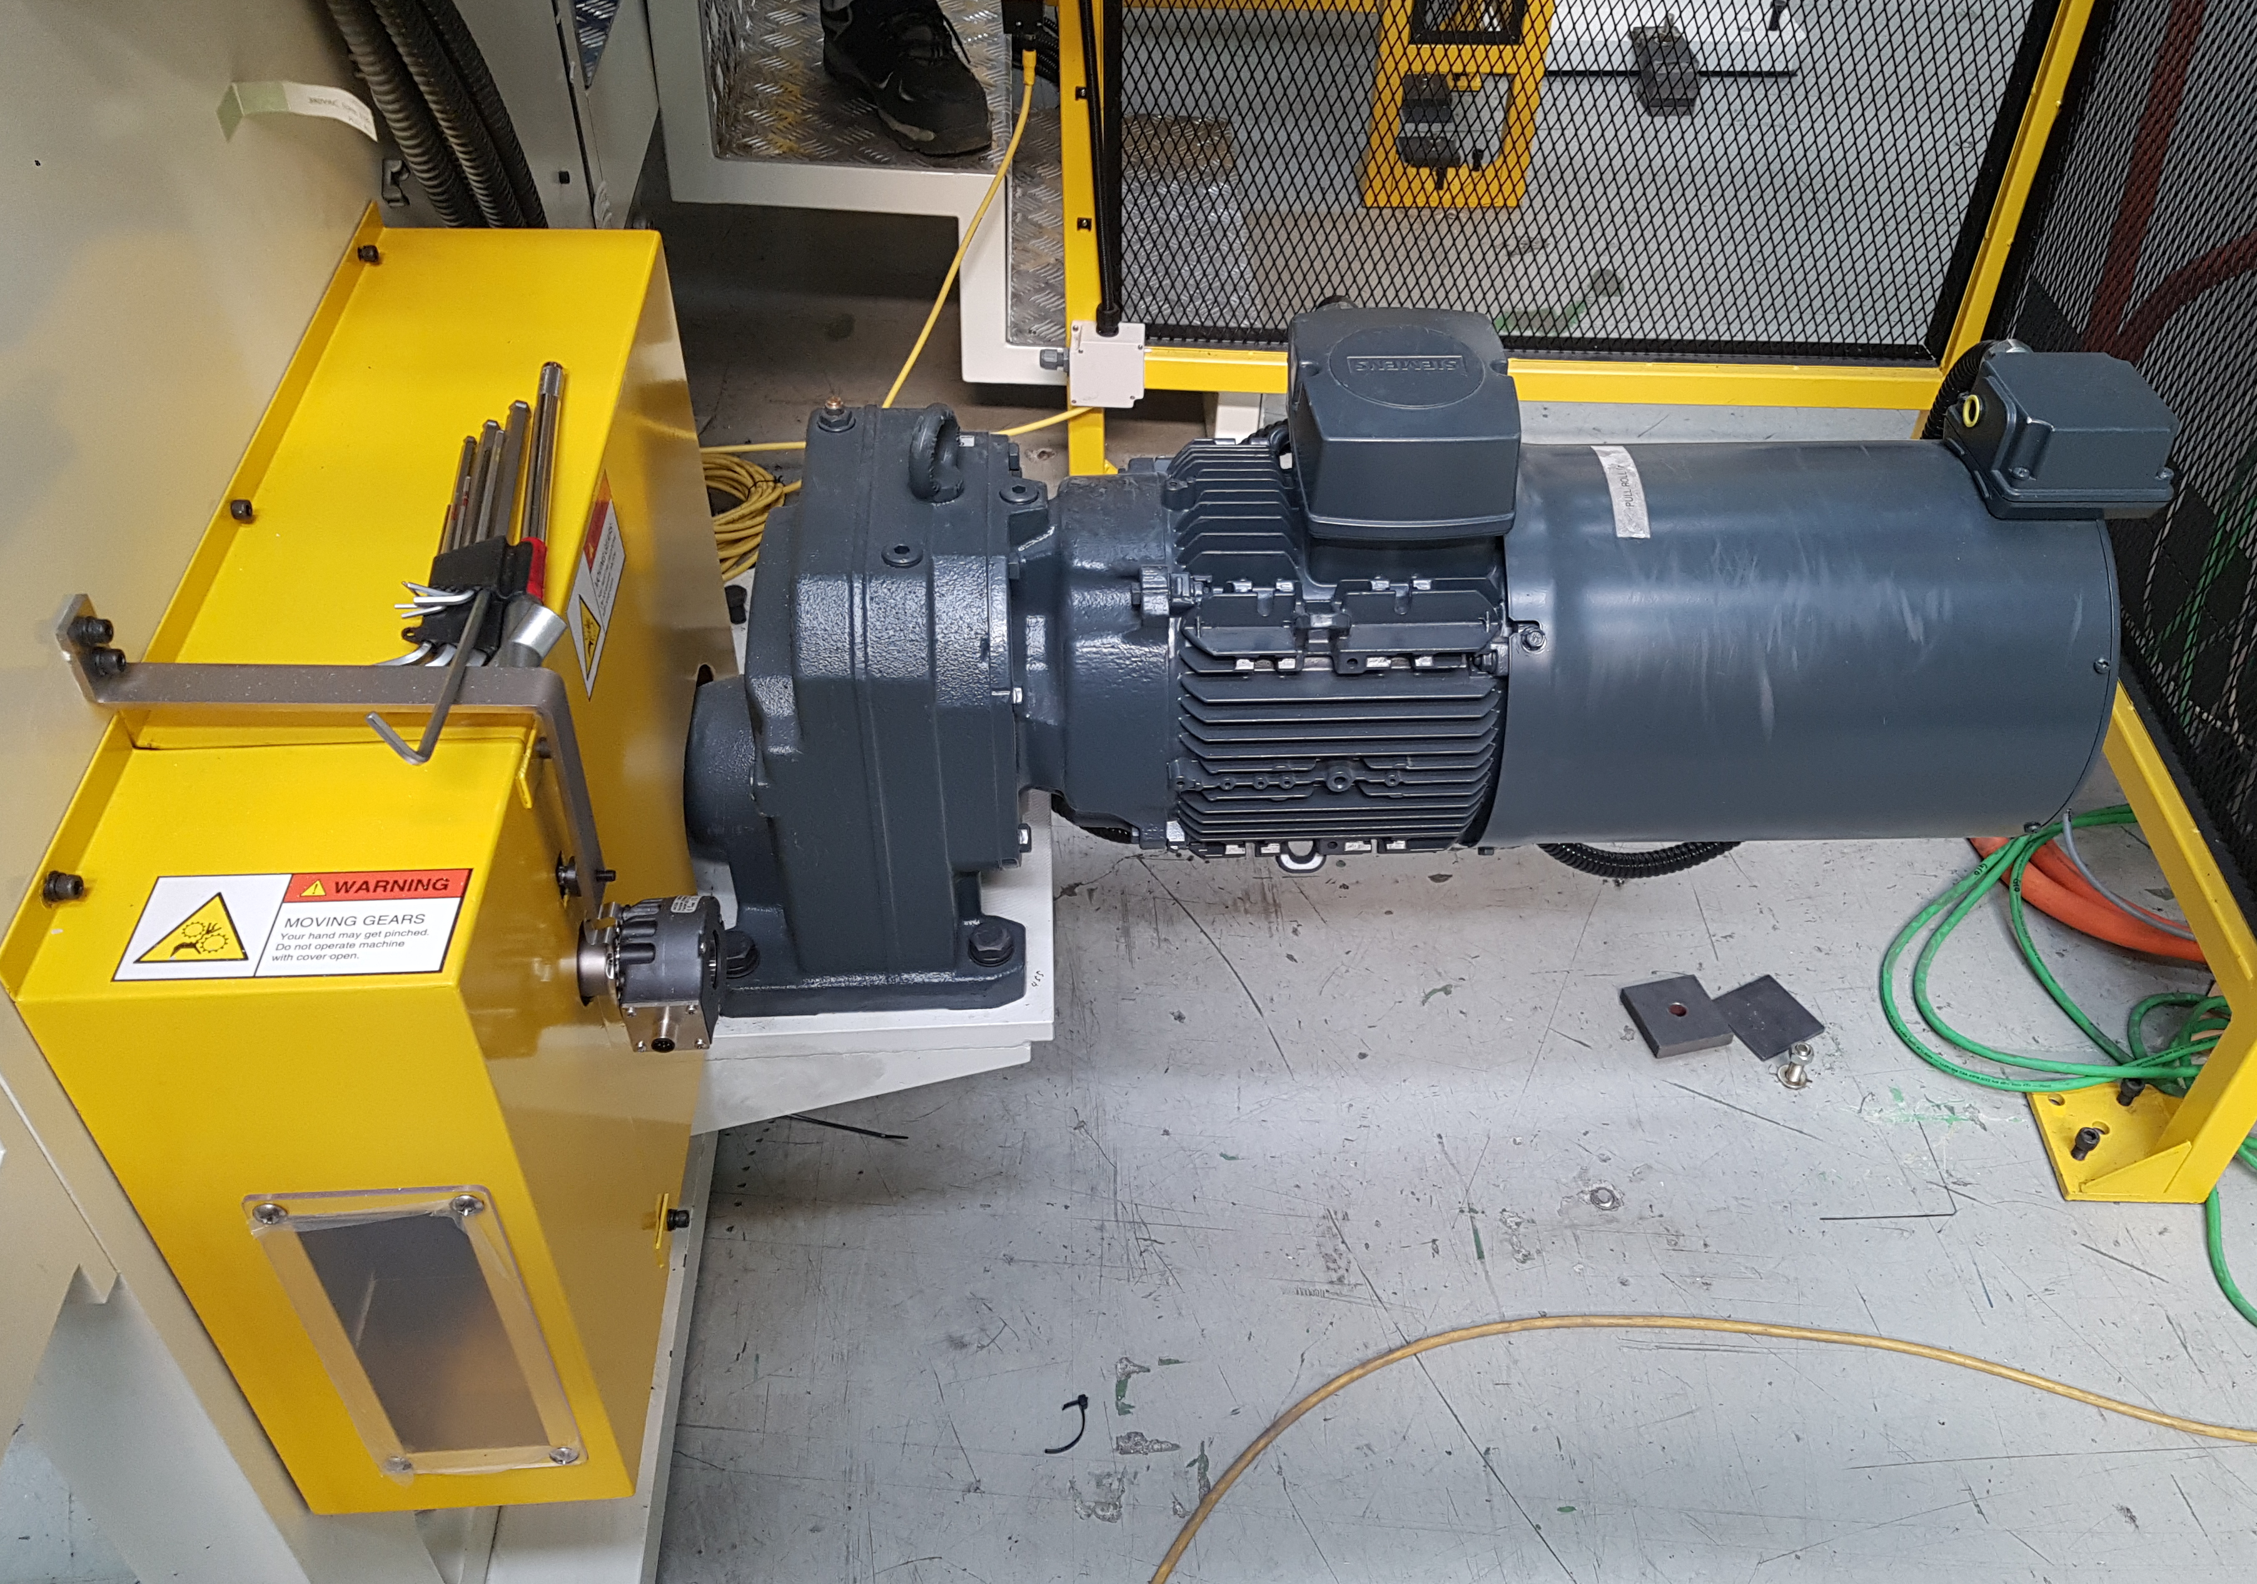
Figure 4H-2. Pull Roll Drive Motor

Operation of the Pull Roll

Pressure and Tensioning
The pressure and tension on each Pull roll is monitored and maintained by a pressure monitor, and air pressure regulator, and tensioned idler rolls mounted with a load cell.

Tension and Alignment Monitor
A pressure monitor attached to a pneumatic cylinder on Pull roll monitors the tension of the web on the drive roll. An attached alignment rod ensures that the web remains aligned through the Pull roll.
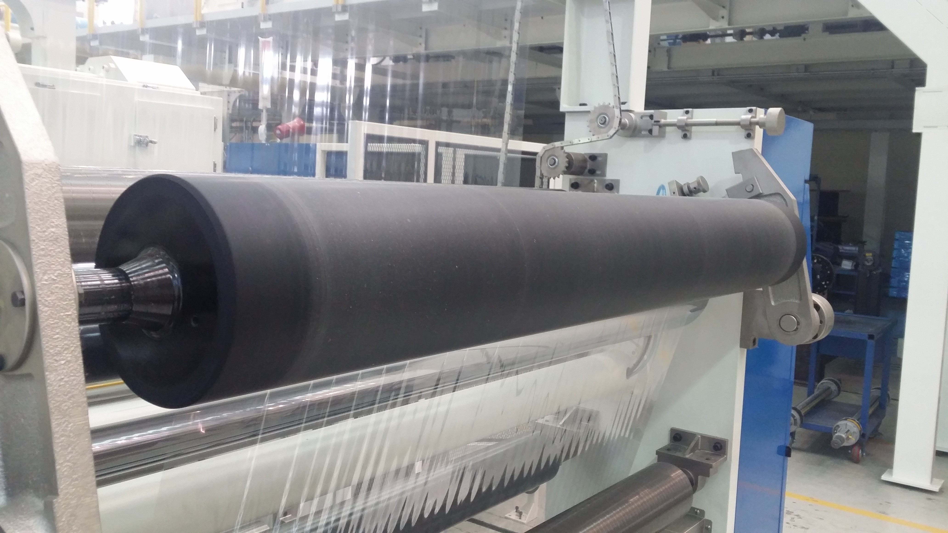
Figure 4H-3. Tension and Alignment Monitor

Air Pressure Regulator
The air pressure regulator moderates and monitors air pressure applied to the nip roll. Set 2~3kgf/cm2 depending on the web material. For normal operation, there is no need to adjust it again.
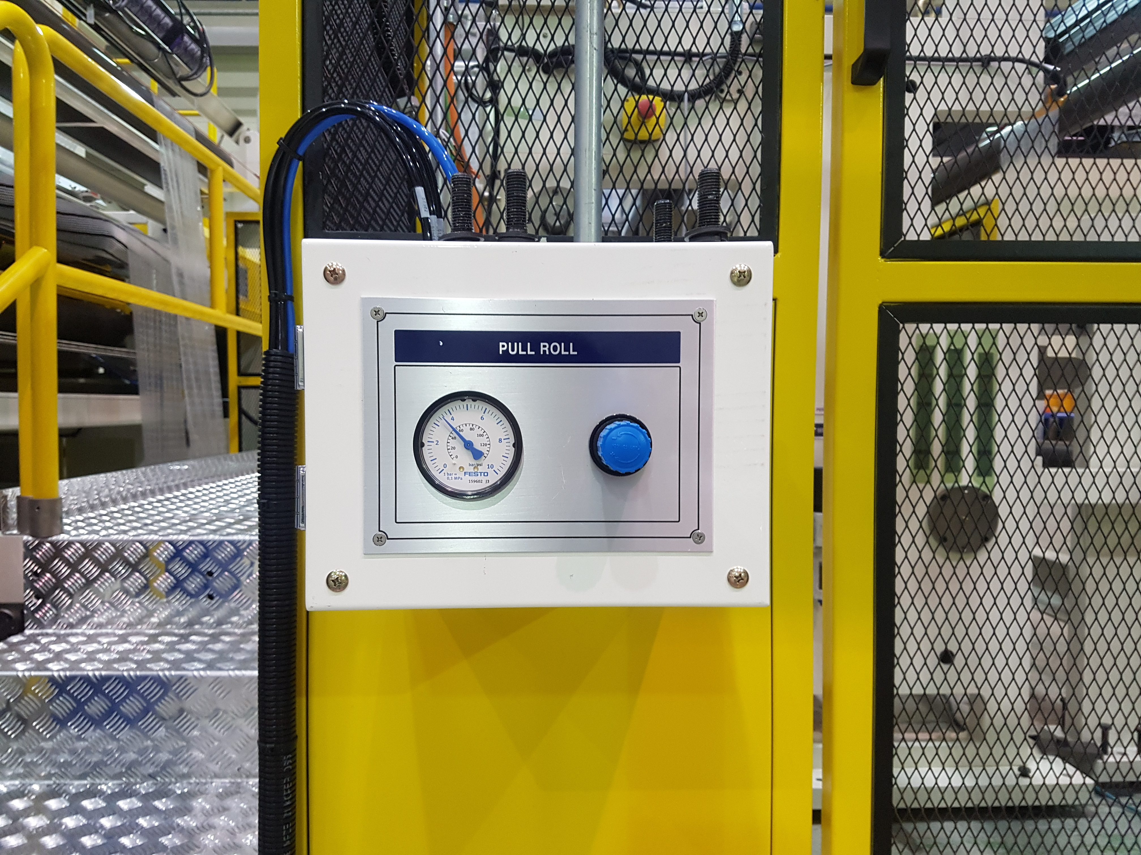  Figure 4H-4. Air Pressure Regulator |  | Figure 4H-5. Load Cell

