Chapter 4F
machine description

Flexo Printer
The Flexo Printer prints on one or simultaneously on both sides of the web.
Contents
About the Flexo Printer 4F-3
Parts of the Flexo Printer 4F-4
Anilox Roll 4F-5
Plate Roll 4F-5
Impression Roll 4F-6
Chamber Doctor 4F-6
Air Pressure Regulator 4F-7
AC Vector Drive Motors 4F-8
Setting Up the Flexo Printer 4F-9
Set the Gap Between Rolls 4F-9
Using the Chamber Doctor 4F-10
Printing onto the Web Substrate 4F-11

Figures
Figure 4F-1. Flexo Printer 4F-3
Figure 4F-2. Flexo Printer (side view) 4F-4
Figure 4F-3. Flexo Printer Parts 4F-5
Figure 4F-4. Impression Roll and Nip Gap Adjusting Handle 4F-6
Figure 4F-5. Air Pressure Regulator 4F-7
Figure 4F-6. Three Main AC Servo Drive Motors 4F-8
Figure 4F-7. Check the gap using pillar gauge 4F-9
Figure 4F-8. Check the gap on the printing plate 4F-10

About the Flexo Printer
The Flexo Printer serves for single side printing of running substrate web for logo printing.
This printing unit is equipped with UV lamps to cure the printing ink on the substrate.
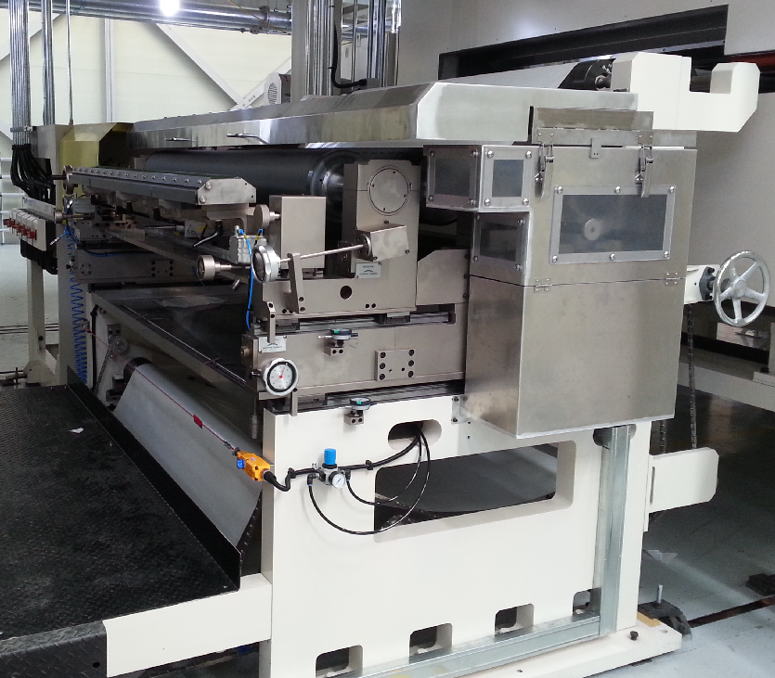
Figure 4F-1. Flexo Printer
The Flexo Printer consists of the following main parts:
- Anilox roll for transferring ink
- Plate roll
- Impression roll
- Nip rubber roll
- Chamber doctor
- Driving Motors

Parts of the Flexo Printer
The Flexo Printer applies printing ink to the web substrate. The printing is applied on the back side of web for logo printing. An idling feature keeps the ink flowing slowly to maintain its fluidity and keep it from clumping when the machine briefly stops.
Web tension is controlled and maintained by an idler roll with an attached load cell.
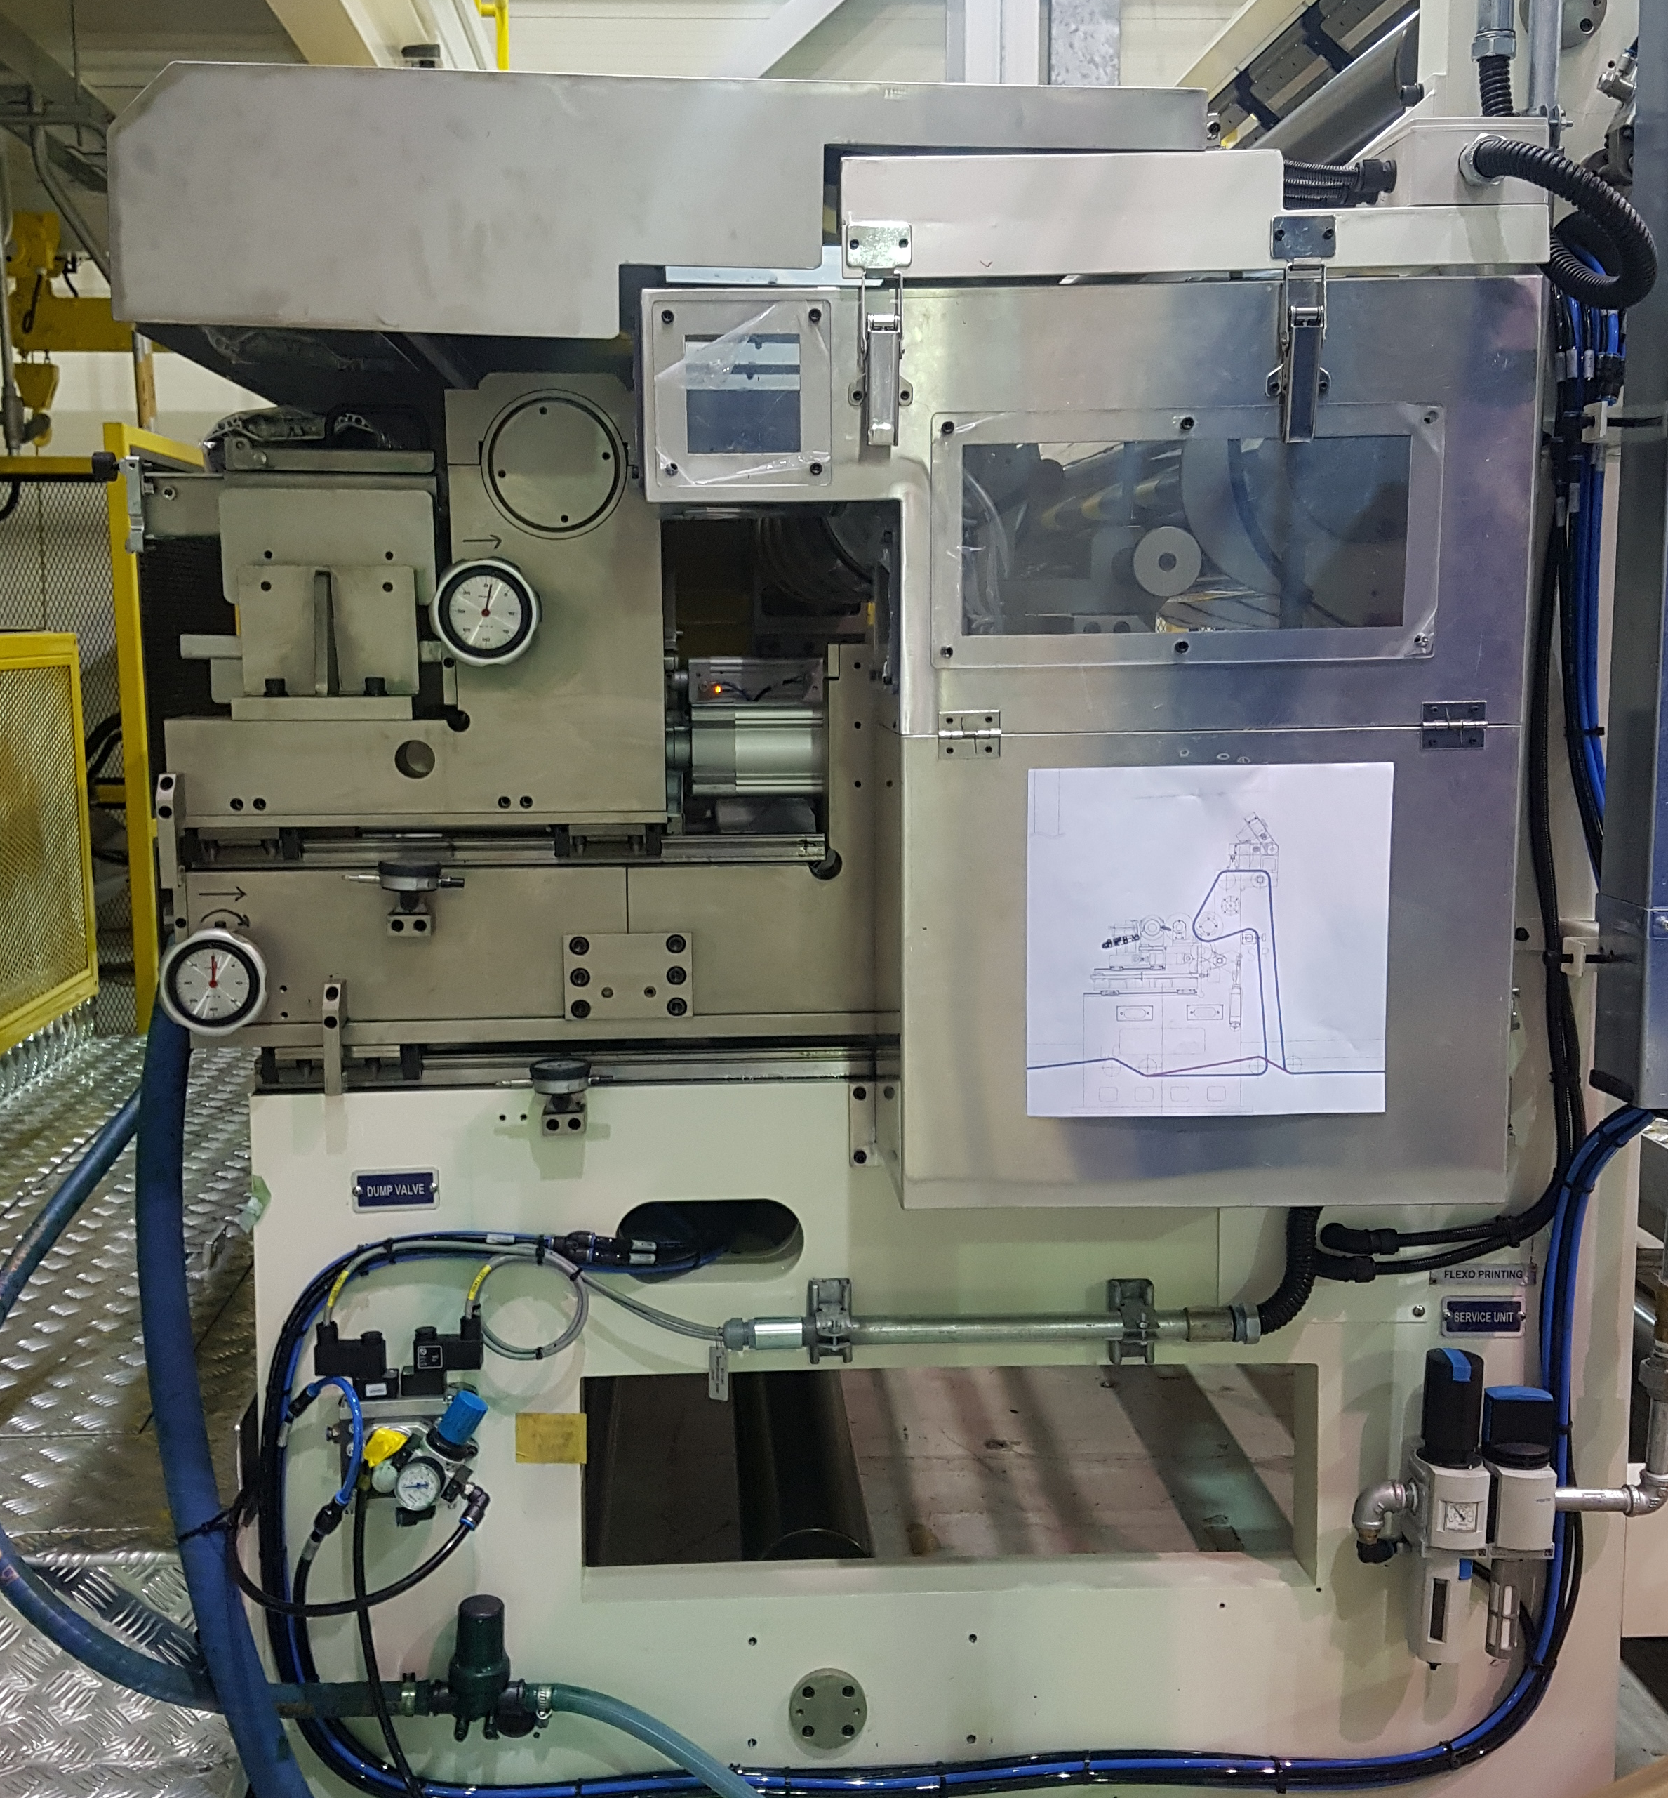
Figure 4F-2. Flexo Printer (side view)

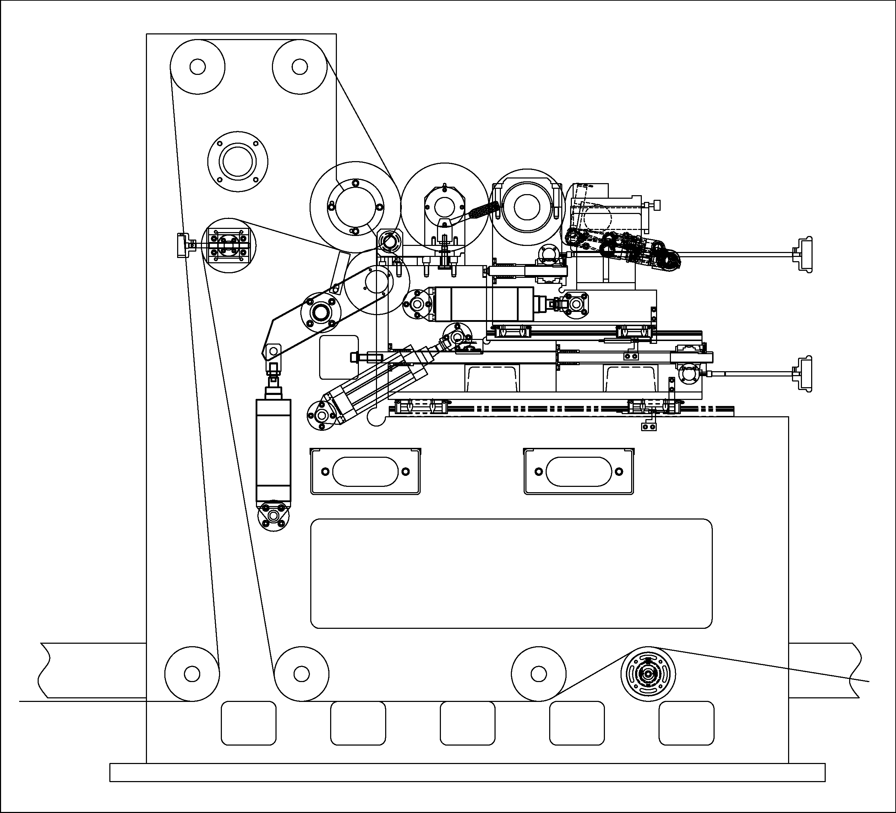
Load Cell
Chamber Doctor
Nip rubber Roll
Impression Roll
Plate Roll
Anilox Roll
Figure 4F-3. Flexo Printer Parts

Anilox Roll
The Anilox roll moves horizontally by pneumatic cylinder to apply pressure and maintain a constant nip gap with the plate roll to transfer printing ink. The gap adjust handles with dial indicators are located both on operating side and driving side for gap adjusting. The Anilox roll is a mandrel type ceramic coated steel roll that has engraved cell of 5cm³/m(3.23BCM). 4kW AC vector geared motors and universal joint drive the Anilox roll.

Plate Roll
The Plate Roll moves horizontally by pneumatic cylinder apply pressure and maintain a constant nip gap with the impression roll to pick up printing ink from Anilox Roll and to apply on the web. The Anilox roll consist of a steel mandrel and a sleeve that has engraved logo Plate. The sleeve can easily be removed for replacement by supplying compressed air. 4kW AC vector geared motors and universal joint drive the Plate Roll.

Impression Roll
The Impression Roll is a fixed roll to surpport the web. The Impression Roll has a Nip Rubber Roll that is operated by pneumatic cylinder to make the independent tention zone. 5.5kW AC vector geared motors and universal joint drive the Impression Roll.
Nip gap adjusting handle between Anilox roll and Plate roll
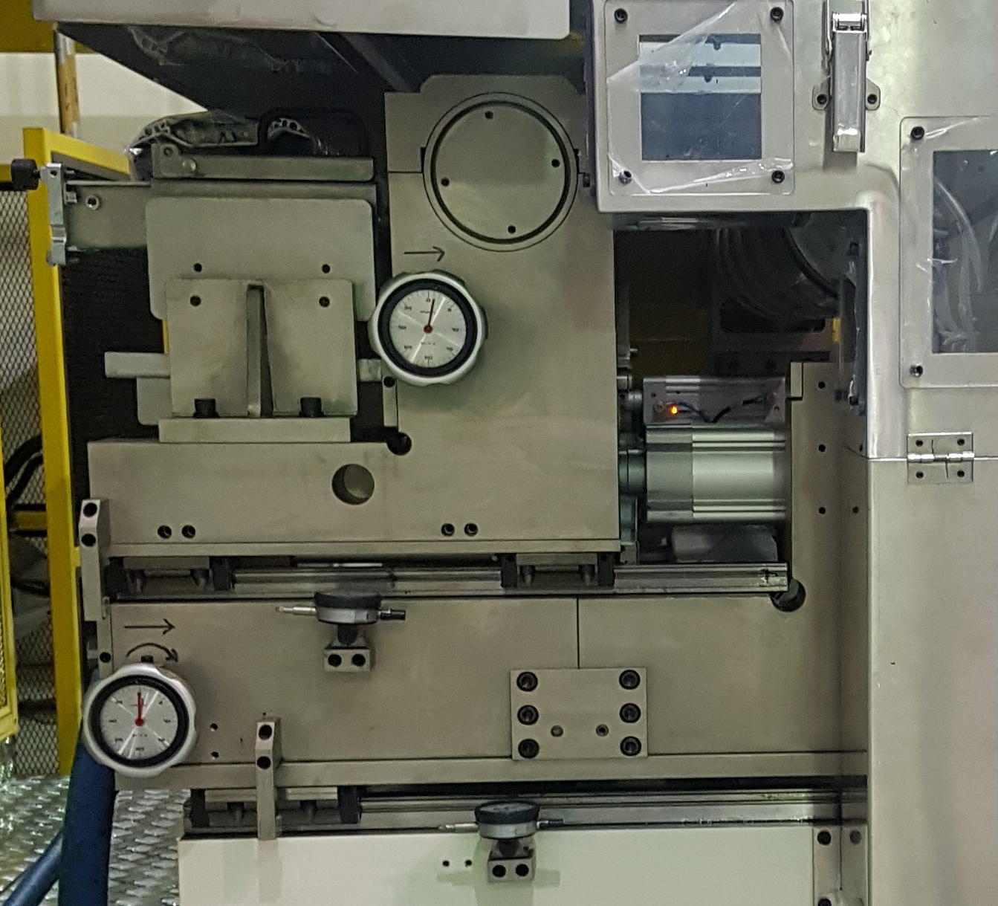
Dial indicate for gap between Anilox roll and Plate roll
Nip gap adjusting handle between Plate roll and Impression roll
Dial indicate for gap between Anilox roll and Plate roll
Figure 4F-4. Impression Roll and Nip Gap Adjusting Handle

Chamber Doctor
The Chamber Doctor supplies printing ink on the Anilox Roll and squeegees the roll with a steel knife to remove excess printing ink from the Anilox Roll before the roll contacts the Plate Roll. The Doctor is rigidly mounted on the Printer unit frame, closely parallel to the Anilox Roll.
The Chamber Doctor moves by suspension system with manual handle. It is able to load the knife and is used to adjust the knife’s pressure. There is also gap adjusting knob to get fine position of Chamber Doctor knife to the Anilox Roll. The knife can be set simply by inserting it into the fixed mounting block and setting the clamp.
The Doctor blade needs to be replaced when there is excess ink not being doctored on the anilox roll.
Refer to the Vendor’s (Akebooth) manual for detailed operation instruction and maintenance.

Air Pressure Regulator
The air pressure regulator moderates and monitors air pressure applied to the nip rolls.
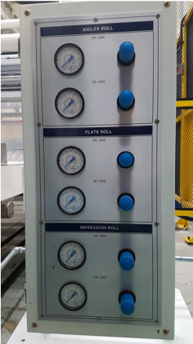
Figure 4F-5. Air Pressure Regulator

AC Vector Drive Motors
Printer has several motors to drive its operation. Three main motors are housed in a bracket bed.
Three AC Vector geared motors those are mounted on a driving bracket transmit power to the Printer through universal joints to the Anilox, Plate, Impression Roll.
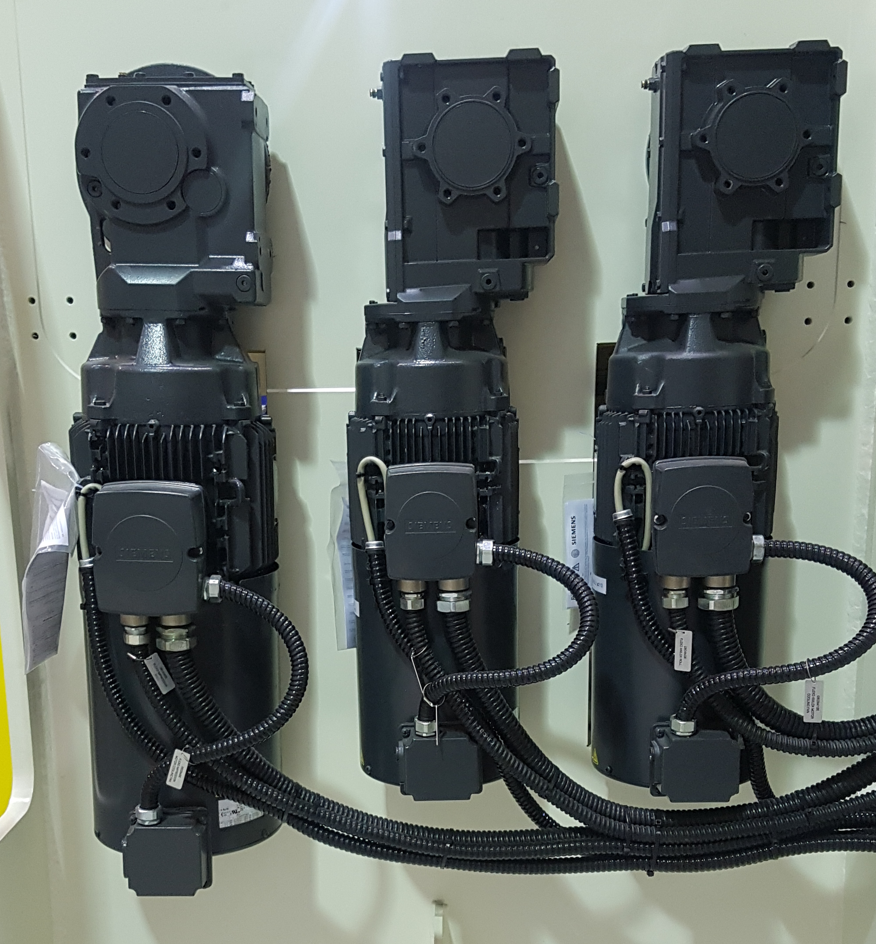
Plate Roll Motor
Anilox Roll Motor
Impression Roll Motor
Figure 4F-6. Three Main AC Servo Drive Motors
The motors drive the rolls through gear reducers. The universal joints have coupling connections.
The motors for Anilox Roll and Plate Roll are controlled in speed matching mode which the linear velocity of roll is same with the line speed. The motor for Impression Roll operates in tension control mode.

Setting Up the Flexo Printer
Setting up the Flexo Printer essentially involves setting the appropriate gaps so that the web properly aligns for printing.

Set the Gap Between Rolls
- Open all the nips of each roll(between Plate roll and Anilox roll, between Plate roll and Impression roll)
- Close the nip between Anilox roll and Plate roll
- Check the Gap of operation side and driving side using pillar gauge. Use a pillar gauge which has same thickness of printing plate.
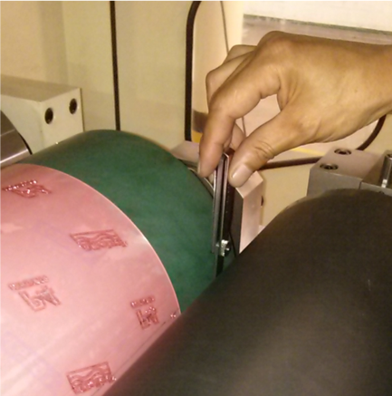
Figure 4F-7. Check the gap using pillar gauge
- Adjust the gaps using gap adjusting handles and make sure the gap of driving side and operation side is same.
- After set the gap of both ends, check the gap between Anilox roll and printing plate using thin film or paper. You can feel the tension of film/paper when you pull out them from the nip. If it is deferent, adjust the gap until you feel the same pressure on the four printing plates.
- Close the nip between the Plate roll and Impression roll.
- Repeat 3 through 6 to set the gap.
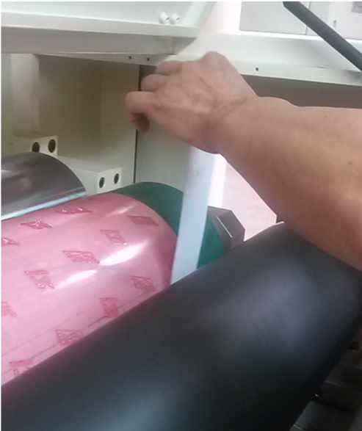

Figure 4F-8. Check the gap on the printing plate

Using the Chamber Doctor

The NOVA XLS (L=2000) chamber doctor from Akeboose is used for Flexo printer. Please see the Vendor’s(Akebooth) manual for detail operation instruction and maintenance.
For general chamber doctor, to prevent any damages on chamber doctor or Anilox roll, understand below procedure.
- Use clean blades which has correct dimension
- Use metal blades for alignment, even though you use a plastic blades
- Make sure the blade are mounted fully flat
- Do not install the side seal plate before install the blades – they may interrupt to install the blade flat
- Adjust the chamber at proper position. Make sure the chamber is square and flat to the Anilox roll using a bubble level
- After checking the level of chamber, bring the chamber in to the anliox roll. The blades must touch very light the roll surface.
- Check the gap between blade and Anilox roll using a pillar gauge(0.0020 inch). Check top and bottom, both ends and center. If all is well, you should feel a “snug” at all point. If something is amiss, you will feel uneven responses from the gauge.
- After check the gap the chamber doctor is ready to run.

Printing onto the Web Substrate
- Set the Chamber doctor properly to the Anilox roll and gap between the rolls before you start the machine
- Locate the chamber doctor in working position
- Start the ink pump to supply UV ink to the Chamber doctor. Make sure there is no leakage at the blade and side seal. Ink must freely return out from the outlet hose of Chamber doctor.
- Start the Anilox roll and Plate to drive in idling speed. If the machine is running, the rolls are driven in line speed.
- Close the nip between Anilox roll and Plate roll. Make sure the ink transfer to the Printing plate from Anilox roll.
- Locate the UV lamp in working position.
- Turn the UV lamp On.
- Close the nip between Plate roll and Impression roll

