Chapter 4B
machine description

Tempering Roll
The Tempering Roll consists of two sets of tempering rolls, each with three rolls. Each set of tempering rolls pairs with a T-die to cool and anneal the extrudate.
Contents
About the Tempering Roll 4B-3
Parts of the Tempering Roll 4B-4
Drawing of the Tempering Roll 4B-4
Two Sets of Three Tempering Rolls 4B-5
Positioning Cylinders 4B-5
Driving Motors 4B-5
Water Temperature System 4B-8
Process Pumping Loop 4B-8
Temperature Sensors 4B-8
Pressure Gauges 4B-8
Heaters 4B-9
Pressure Relief Valve 4B-9

Figures
Figure 4B-1: Tempering Roll Drawing 4B-4
Figure 4B-2. Tempering Roll Positioner Drawing 4B-4
Figure 4B-3. Tempering Roll 4B-5
Figure 4B-4. Tempering Roll Driving Drawing 4B-6
Figure 4B-5. Tempering Roll Driving Drawing 4B-6
Figure 4B-6. Timing Belt Tension Idler 4B-6
Figure 4B-7. Air Pressure Regulator 4B-7
Figure 4B-8. Tempering Roll driving Cover 4B-7

About the Tempering Roll
The NAIB Line 5 machine has six extruders. The Extruders feed and melt solid pellets with heat and pressure. The resultant polymer will extrude into the dies from the feed pipes and feedblock with layer multiplier.
The extrudate is cooled, annealed, and stretched through the Tempering Roll unit, a series of tempering rolls. The temperature of each tempering roll is controlled by water.
The Tempering Roll unit consists of:
- Two sets of three tempering rolls : Back side (Top back, Middle back, Bottom back) Tempering rolls and Front side (Top front, Middle front, Bottom front) Tempering rolls
- The tempering roll positioning cylinders
- Driving motors
There are total three (3) AC vector motors to drive tempering rolls and each motors are connected to two(2) tempering rolls – top, middle and bottom rolls.

Parts of the Tempering Roll

Drawing of the Tempering Roll
The Tempering Roll consist mainly of six tempering rolls, positioning cylinders, belt adjusting cylinders, and drive motors.

Top back tempering roll
Top front tempering roll
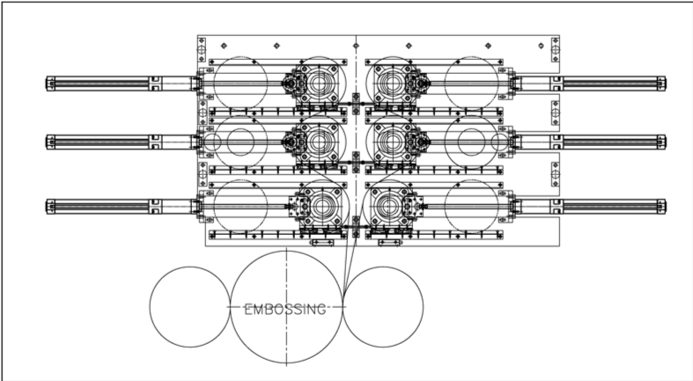
Bottom back tempering roll
Middle back tempering roll
Beam sensor
Bottom front tempering roll
Middle front tempering roll
Figure 4B-1: Tempering Roll Drawing
Tempering roll
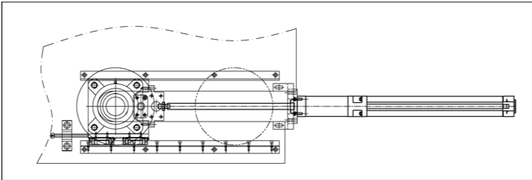
Stopper
Linear guide
Tempering roll positioning cylinder
Figure 4B-2. Tempering Roll Positioning Cylinder Drawing

Two Sets of Three Tempering Rolls
Each T-die extrude molten polymer onto three chill rolls for annealing and stretching the extrudate. Top Tempering roll is located under the T-die, then Middle Tempering roll and Bottom Tempering roll are followed. The Tempering rolls are temperature controlled by water to anneal the extrudate.
All tempering roll has diameter of 203.2 mm (8”), made with double-shell spiral fluted and equipped with bearing housings, belt pulleys and rotary unions.
All tempering rolls are supplied by SEE.
 |  | The surface of the Dies is very hot. Use caution and wear appropriate clothing as well as heat resistant gloves, long sleeve shirt and face shield.

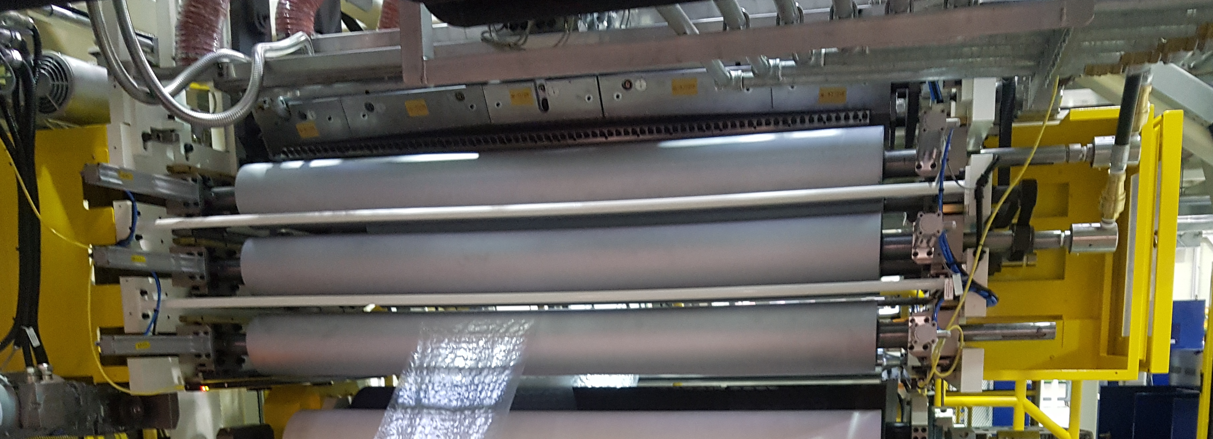
Figure 4B-3. Tempering Roll

Positioning Cylinders
Each tempering roll moves in and out activated by pneumatic cylinder.
Tempering rolls are to be moved out when purge or drool is in process. Once clear plastic films are extruded from T-dies, tempering rolls shall move into the in position for production.
There are two beam sensors interlocked with Tempering roll movement and rotation to prevent an operator’s head or hands get pinched between Tempering rolls. A laser area scanner is mounted at the back side of Embossing carriage to prevent Tempering roll movement and rotation when the Embossing carriage is in home or maintenance position.
When working under the Tempering Roll unit, always follow safe procedures for working near heated components and molten plastic.

Driving Motors
There are three 2.2 kW AC vector geared motors driven by timing belts on the Tempering Roll unit. These motors operate under draw speed to regulate the speed of the web (resin) through the six tempering rolls.
Top tempering roll driving motor
Pneumatic cylinder-actuated belt idlers maintain proper tension to the timing belts when the tempering rolls are moving.
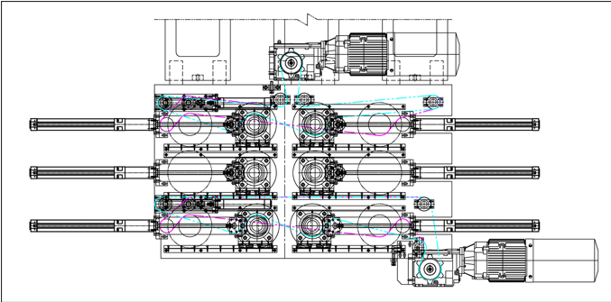
Bottom tempering roll driving motor
Timing belt tensioner cylinder
Timing belt
Timing belt tensioner cylinder
Timing belt tensioner cylinder
Figure 4B-4. Top and Bottom Tempering Roll Driving Drawing
Middle tempering roll driving motor
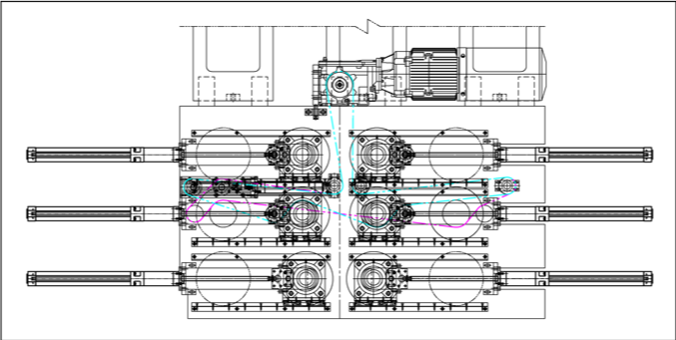
Timing belt tensioner cylinder
Figure 4B-5. Middle Tempering Roll Driving Drawing
Timing belt tensioner cylinder

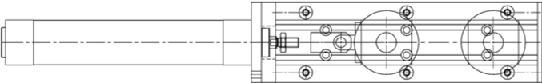
Timing belt idler

Figure 4B-6. Timing Belt Tension Idler

Air Pressure Regulator
The air pressure regulator moderates and monitors air pressure applied to the pneumatic cylinder for timing belt idler.
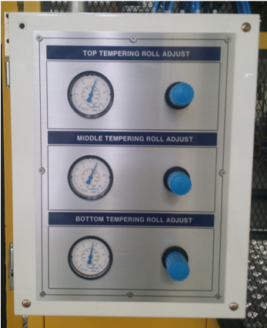
Figure 4B-7. Air Pressure Regulator

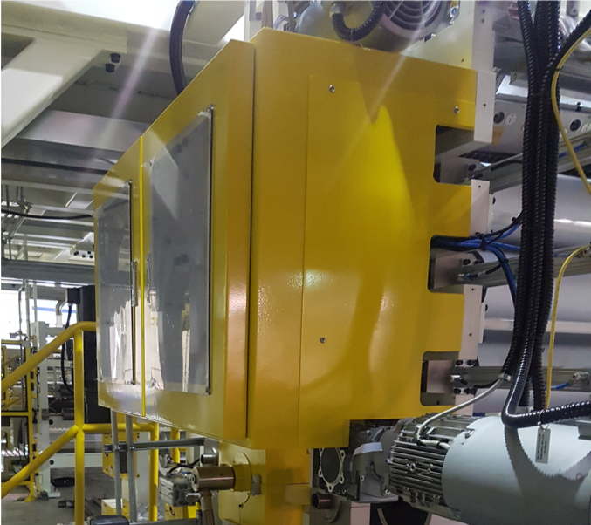
Figure 4B-8. Tempering Roll Driving Cover

Water Temperature System
It is critical to control the water temperature flowing through each tempering roll.
Chilled water supply to the water tempering unit is by the customer including supply and return manifolds.
Each process pumping system is designed to deliver a high volume flow to the process at an adjustable temperature. Although they differ in capacities, all process pumping systems are identical in design and operation.

Process Pumping Loop
Pumps and motors control and monitor the water that runs through the tempering rolls, in addition to a thermometer, pressure gauges, temperature sensor, a pneumatically positioned control valve, a current-to-pneumatic (I/P) transducer, and the temperature controller also.
Each process water pump obtains its supply water from two sources – one source is directly from the process line and the other is from the chilled water header. The recirculation line contains a manually operated throttling valve that is used to set the back pressure in the line. A temperature sensor monitors the temperature of the water entering the roll and provides a feedback signal to the temperature controller. The controller then provides a proportional output signal to an I/P converter that regulates a temperature control valve in the chiller return line. As this valve opens, more water is returned to the chiller to be re-cooled.
Maintenance shut-off valves are located in the pump suction and discharge lines.

Temperature Sensors
A dual scale thermometer (Centigrade and Fahrenheit), located in the pump discharge line, monitors the temperature of the water supplied to the process. A sudden increase or decrease in temperature from the normal operating point indicates that the control valve is malfunctioning.
A “J” type thermocouple is installed in the pump discharge line prior to the heat transfer roll. The control thermocouple provides a feedback signal to the temperature controller used to control the temperature of the water supplied to the process.
A second thermocouple on the process return line provides a monitoring signal. The difference between the temperature readings on the two thermocouples indicates the amount of temperature increase across the roll, generally about 2–3°F (1.11–1.66°C).

Pressure Gauges
A dual scale (PSI and KPA) liquid-filled pressure gauge, mounted at the process water pump, monitors the discharge pressure. A needle valve protects the gauge from being damaged by pressure surges within the system. A second gauge and needle valve are located in the tank return line. The needle valves operate opened at about ¹⁄8 of a turn.

Heaters
The process pumping loops include immersion-type heaters. These heaters are located in the process supply line between the pump and the roll to allow heating of the process water. They also more precisely control the water temperature while running.
Whenever the water temperature falls below the setpoint, the heater turns on to raise the temperature to its setpoint. If the temperature exceeds the setpoint value, then the pneumatic water valve automatically adjusts to allow more water to return to the chiller.
The heater is electrically interlocked; it cannot operate unless a flow switch detects that the process pump is running and water flow is established.

Pressure Relief Valve
A pressure relief valve, located between the pump and the chill roll, opens if the water pressure exceeds 125 PSI to prevent damage to the temperature-control system. This valve must be piped to a safe drainage location during installation.

