Chapter 4A
machine description

Extruders
The NAIB Line 5 machine includes six Extruders. The Extruders feed and melt solid pellets with heat and pressure, then extrude the resultant polymer into the Tempering Roll to make film.
Contents
About the Extruders 4A-5
Part Drawings of the Extruders 4A-6
Parts of the Extruders 4A-9
Base Platform 4A-9
Drive Motors 4A-9
Gear Reducers 4A-9
Feed Cylinders 4A-11
Barrels 4A-12
Barrel Zones 4A-14
Heating and Cooling 4A-15
Screws 4A-15
Screw Cooling 4A-16
Manual Screw Pusher 4A-16
Piping and Wiring 4A-16
Screen Changers 4A-16
Melt Pumps 4A-17
Resin Specifications 4A-17
Smoke Hoods 4A-17
Instrumentation and Controls 4A-19
Melt Pressure 4A-19
Melt Temperature Sensor 4A-19
Temperature Control Sensors 4A-20
Thermocouple Break Protection 4A-21
Rupture Disc 4A-21
Starting the Extruder 4A-23
Heat the Extruder Barrels 4A-23
Monitor Progress 4A-23
Heat the Zones 4A-24
Heat the Dies 4A-24
Open the Extruder Head 4A-24
Fill the Feed Cylinders 4A-25
Start the Screws 4A-25
Increase the Rotating Speed 4A-25
Clean Drool from the Dies 4A-27
Operating Modes 4A-28
Shutting Down the Extruder 4A-29
Shutting Down a Loaded Extruder 4A-29
Shutting Down and Purging the Extruder 4A-29
Restarting after Shutdown 4A-30

Figures
Figure 4A-1. Extruders 4A-5
Figure 4A-2. ø115 mm Extruder Drawing 4A-6
Figure 4A-4. ø90 mm Extruder Drawing 4A-6
Figure 4A-5. ø75 mm Extruder Drawing 4A-7
Figure 4A-6. ø65 mm Extruder Drawing 4A-7
Figure 4A-7. ø50 mm Extruder Drawing 4A-8
Figure 4A-3. Extruders Mezzanine Drawing 4A-8
Figure 4A-8. Screw Drive Motor 4A-9
Figure 4A-9. Gear Reducer 4A-10
Figure 4A-10. Lubrication Circulating System 4A-11
Figure 4A-12. Feed Cylinder 4A-11
Figure 4A-11. ø90 mm Screw Feed Cylinder 4A-12
Figure 4A-13. Barrel and Cooling Fans 4A-13
Figure 4A-14. Thermocouple 4A-13
Figure 4A-15. Barrel Component Drawing 4A-14
Figure 4A-16. Single-Mixer Screw 4A-15
Figure 4A-17. Cooling System to the Feed Cylinder 4A-16
Figure 4A-18. Smoke Hoods 4A-18
Figure 4A-19. Rupture Disc Parts 4A-22

Tables
Table 4A-1. Barrel Zones 4A-14
Table 4A-2. Resin Specifications 4A-17
Table 4A-3. Screw RPM Throughput Example Graph 4A-26

About the Extruders
The NAIB Line 5 machine has six Extruders that feed the Tempering Roll on the Embossing Carriage. Each Extruder has a screw for melting the pellets to create the extrudate: one ø50 mm, two ø65 mm, one ø75 mm, one ø90 mm, and one ø115 mm.
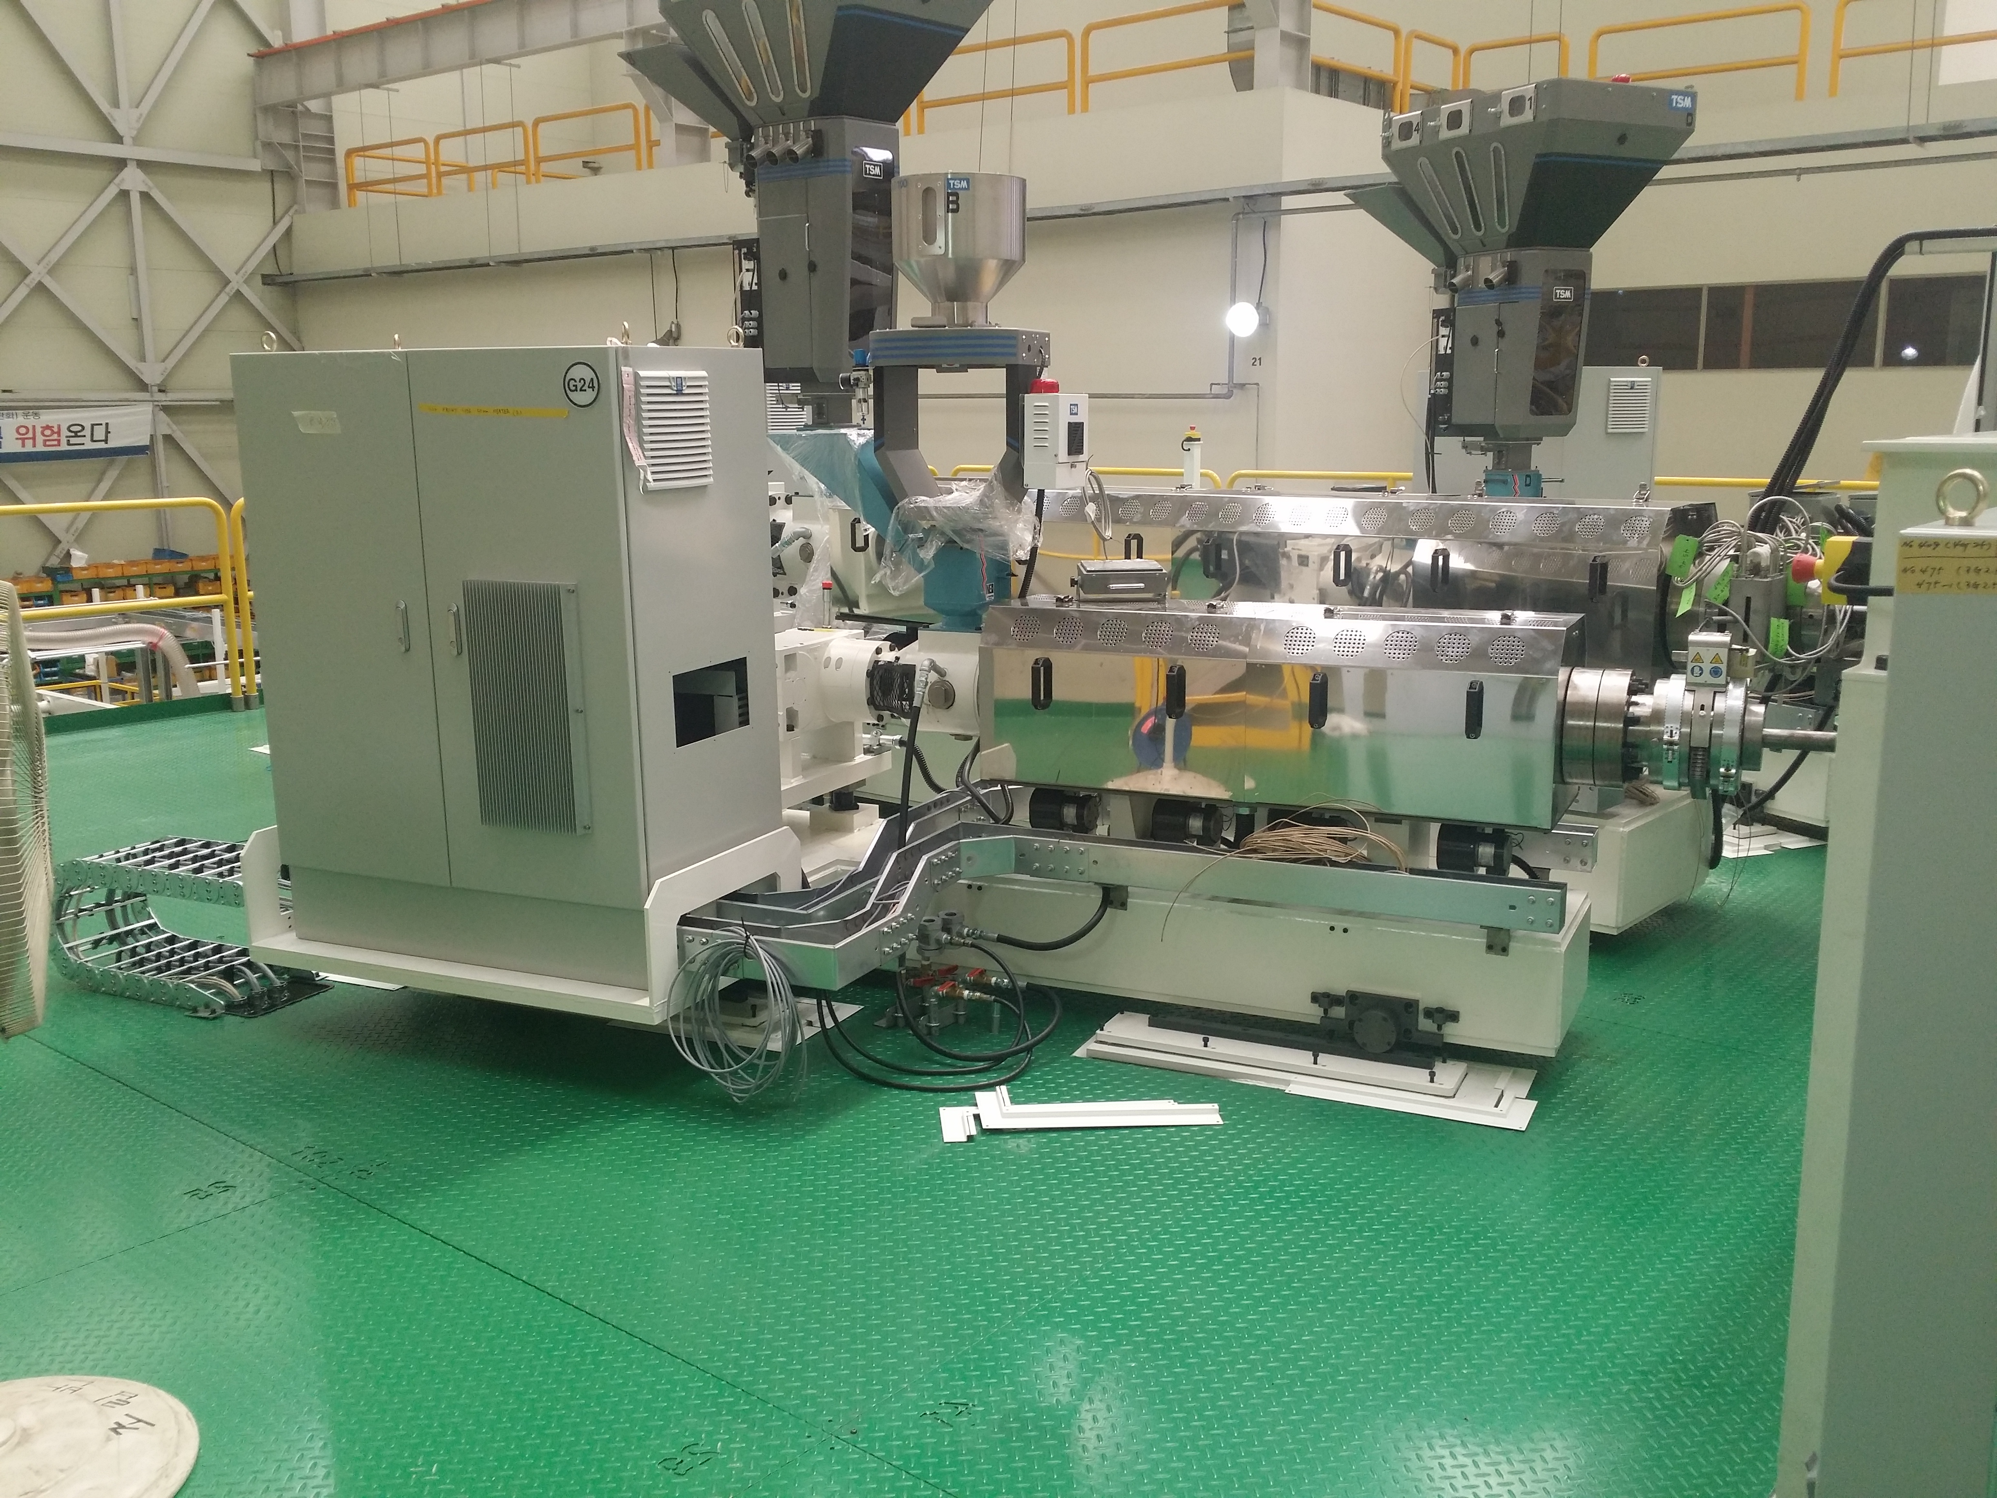
Figure 4A-1. Extruders
The Extruders can run at a maximum operating pressure of 351 kg/cm²; the maximum barrel pressure is 703 kg/cm²; the nominal rupture disc rating is 527 kg/cm².

Part Drawings of the Extruders
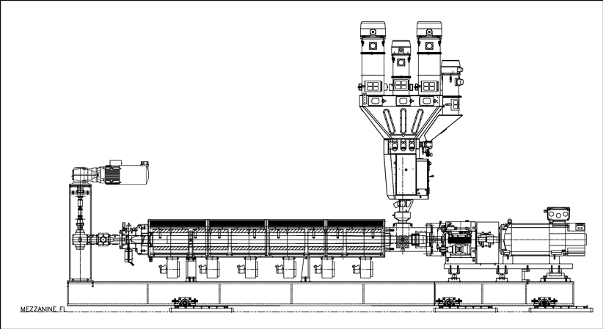
Feed cylinder
Resin blender
Screw
Barrel Heater
Melt pump
Cooling Fan
Barrel
Screen changer
Driving Motor
Figure 4A-2. ø115 mm Extruder Drawing

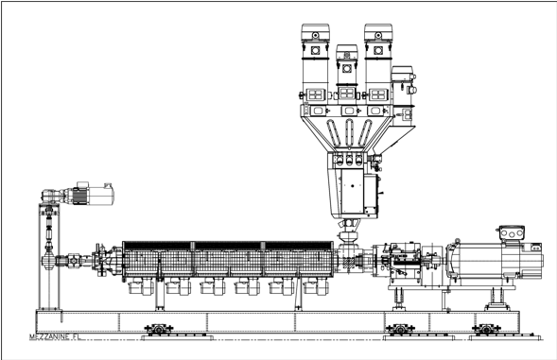
Figure 4A-3. ø90 mm Extruder Drawing

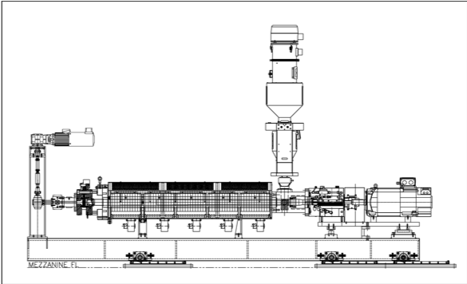
Figure 4A-4. ø75 mm Extruder Drawing

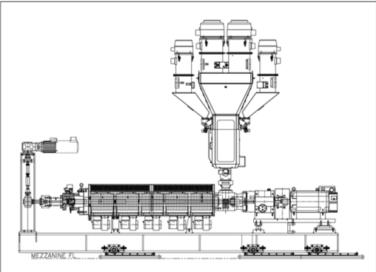
Figure 4A-5. ø65 mm Extruder Drawing

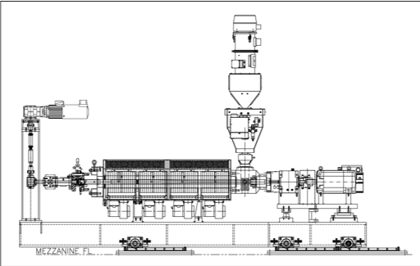
Figure 4A-6. ø50 mm Extruder Drawing

Extruder Drive Cabinet
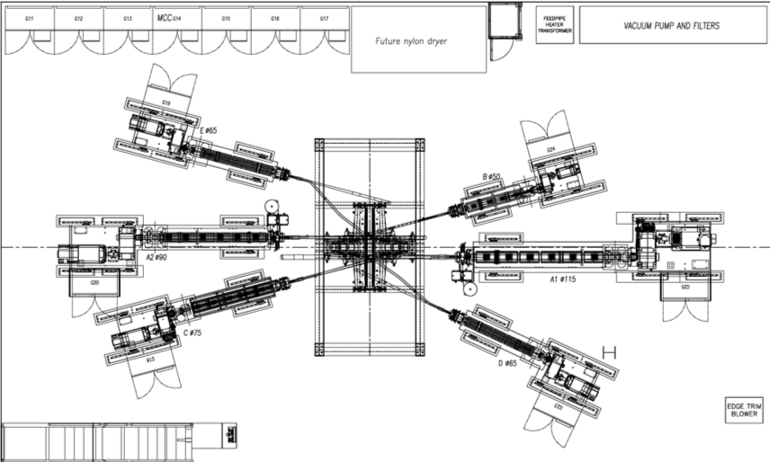
Extruder Heater Cabinets
Figure 4A-7. Extruders Mezzanine Drawing

Parts of the Extruders

Base Platform
The base platform supports the heavy components of the Extruders to provide structural rigidity and strength. During installation, the barrel, feed cylinder, and gear reducer should be aligned properly to ensure that the screw does not contact the inside of barrel. The barrel support aligns the barrel and provides support for the feed pipe equipment.
The base platform allows heat expansion of the barrel to minimize structural stress. At the drive side, a rigid steel plate attached to the gear reducer and motor slides back and forth on ball casters and sliding blocks when the Extruders are heated.
The base platform is constructed from heavy-duty steel rectangular beams, precision machined for accurate alignment. It is designed to support the Extruders for thermal expansion.

Drive Motors
The Extruder screws are driven by electric drive motors through parallel shaft helical gear speed reducers. This double-reduction provides the proper overall gear ratio for the range of screw speeds.
Drive motors sit at the back of the base platform. The ø115 mm screw is powered by a 150 kW drive motor, the ø90 mm screw by a 150 kW drive motor, the ø75 mm screw by a 55 kW drive motor, the ø65 mm screws by 39 kW drive motors, and the ø50 mm screw by a 19 kW drive motor. All drive motors are Siemens motors with Zambello gear reducers.
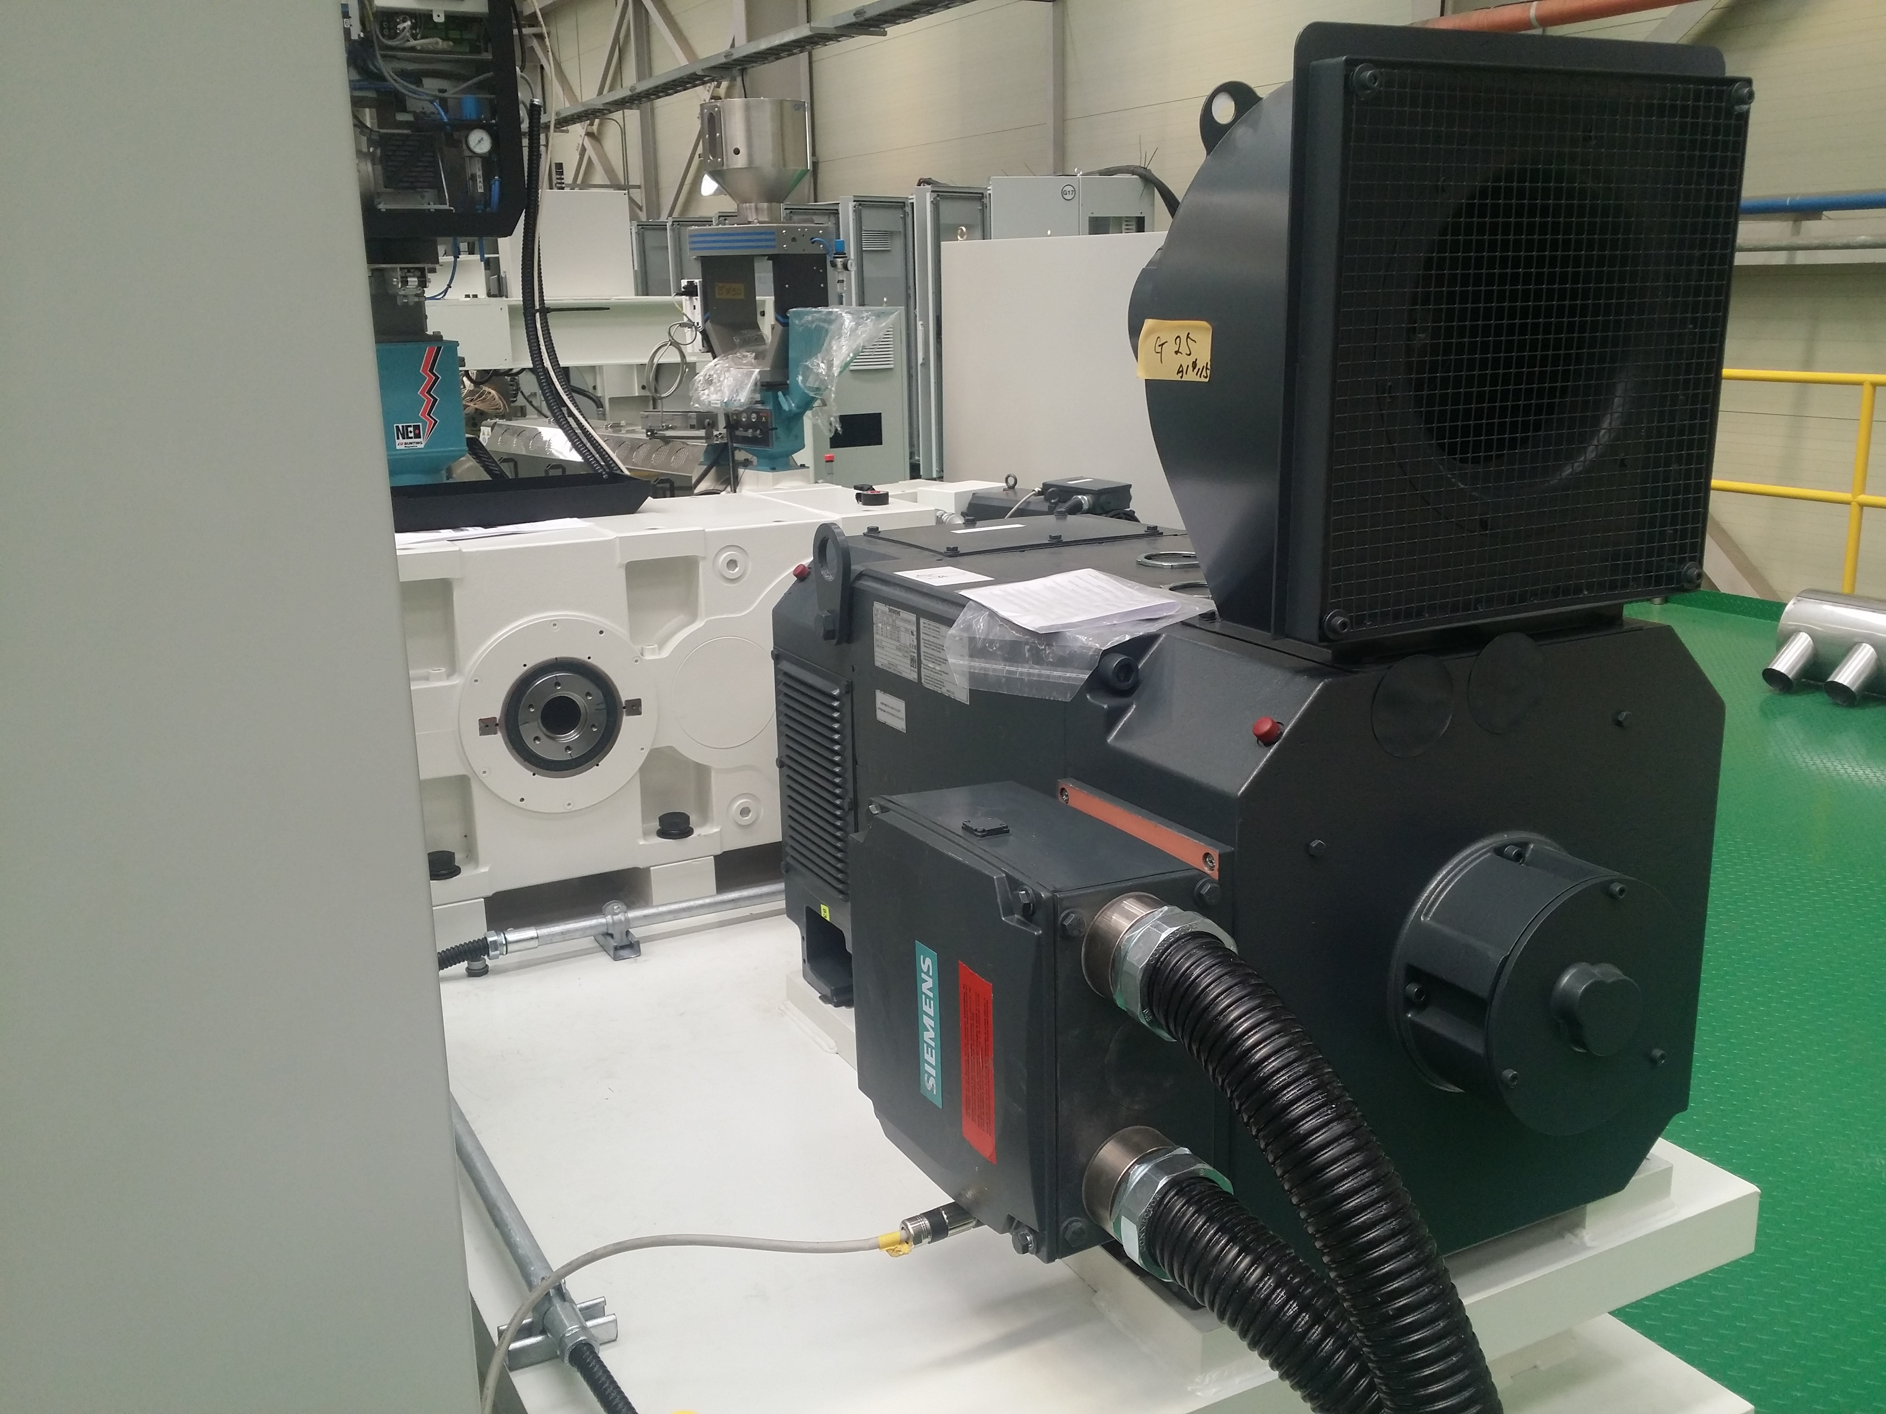
Figure 4A-8. Screw Drive Motor

Gear Reducers
The high speed of each motor is reduced to the low operating speed of the screw by using a gear reducer, increasing the motor torque. Each gear reducer is a double reduction unit with parallel shaft helical gears, which is supplied with the proper overall gear ratio for the design range of screw speeds. There is an Emergency Stop Button for each screw on top of the gear reducers.
Generally, direct drive with a suitable gear coupling is used to transmit the power to the gear reducer.
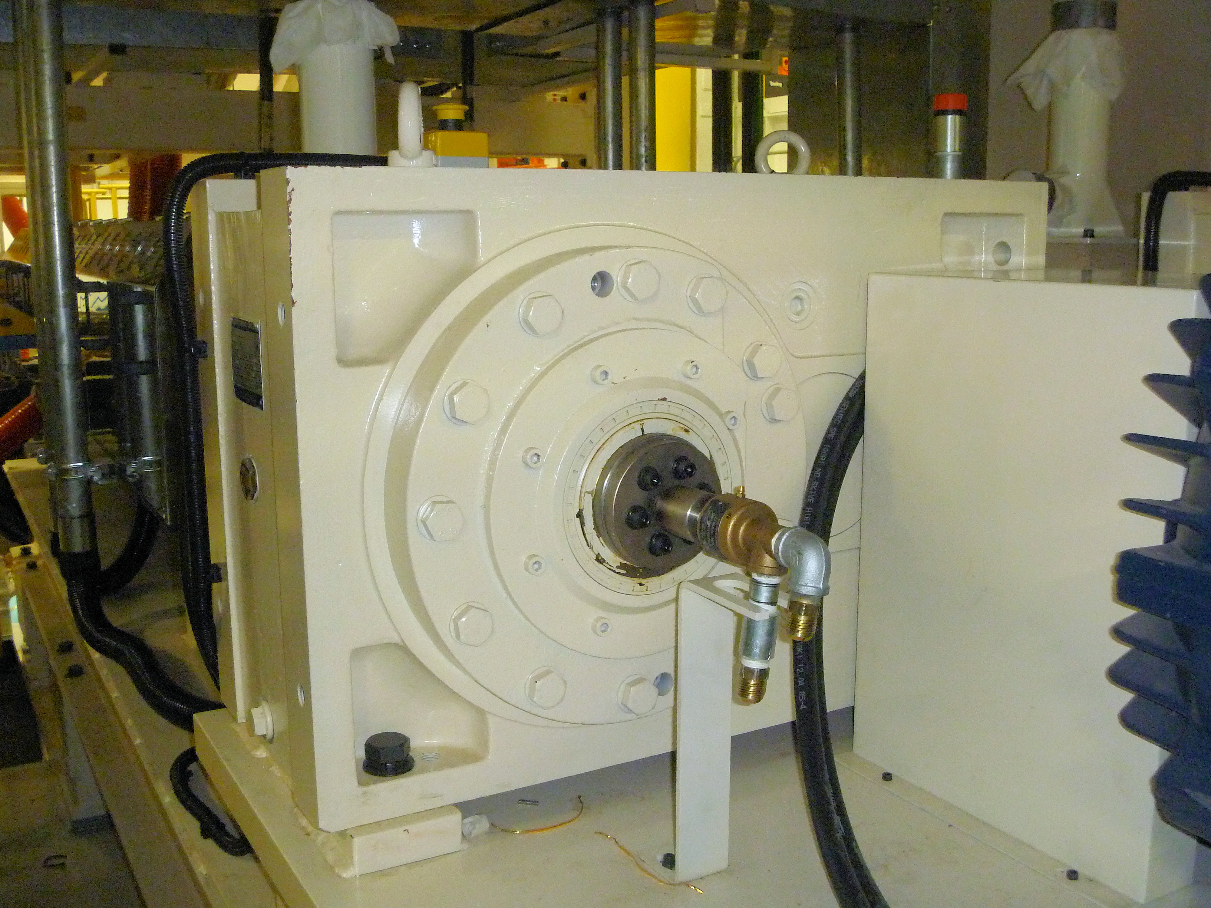
Figure 4A-9. Gear Reducer
The gear coupling has fully crowned teeth, is directly coupled to the motor and the gear reducer, and transmits only torsion force. The present gear ratio is set for each Extruder’s screw design. The gear reducer’s double-reduction helical gears are hardened and ground, and includes an integral oil cooling system with a pump and a heat exchanger.
The motors drive the gearbox through a gear coupling and gear reducer. Both are enclosed in a protective safety guard. Do not remove the safety guard while power is on nor operate machine with the safety guard removed.
A breather at the top of the gear reducer allows the air in the gear reducer to expand and contract. The breather, the area around it, and the filtering element must be kept clean to ensure its proper operation.
Use the sight glass at the side of the gear reducer to monitor the oil level and provide a visual inspection of the operation. Excessive foaming or severe discoloration indicates problems.

Lubricating the Gear Reducer
A piping system and a pump coupled to the gear shaft circulates lubricating oil to the critical lube points within the gear reducer. The circulating system consists of a shaft-driven pump and plate-type heat exchanger. The pump pulls oil from the gear reducer and circulates it through the heat exchanger for cooling. The cooled oil then reenters the upper part of the gearbox. The gearboxes for the ø115 mm, ø90 mm, and ø75 mm screw Extruders have a pump for lubrication and cooling. A pressure sensor and a flow meter detect the flow of oil. The gear boxes for ø65 mm and ø50 mm screw Extruders are cooled and lubricated by flapping and a removable coil.
The main gears are partially submerged in the lubricant so that they lubricate properly even when the screw speed is very low. The pump is closely coupled to the drive shaft of the gear reducer. Because the volume of the pumped oil varies as the drive speed varies, this flooded lubrication system works in conjunction with the circulating system.
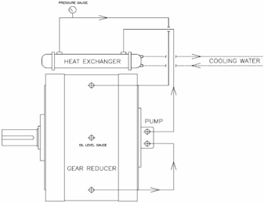
Figure 4A-10. Lubrication Circulating System
Depending on the screw speed and the size of the gear reducer, the heat exchanger might need to keep the temperature of the lubrication oil within operating range. The heat exchanger is located in the pressure line just after the pump for cooling the oil before it is returned to the gear reducer. Cooling water must be connected to the heat exchanger.
Cooling water must be piped into and out of the heat exchanger. The cooling water temperature is of critical importance: 25°C–27°C is recommended. If it is too cold, it could cause improper flow, resulting in a lack of lubrication. Manual valves in the water lines to and from the heat exchanger are used to regulate the water flow.

 |  | Make sure the manual valve is open before starting the pump. Do not close the valve while the pump is running.

Feed Cylinders
The feed cylinder is bolted between the barrel and the gear reducer. It provides a throat for the pellets to enter the Extruders from the hopper.

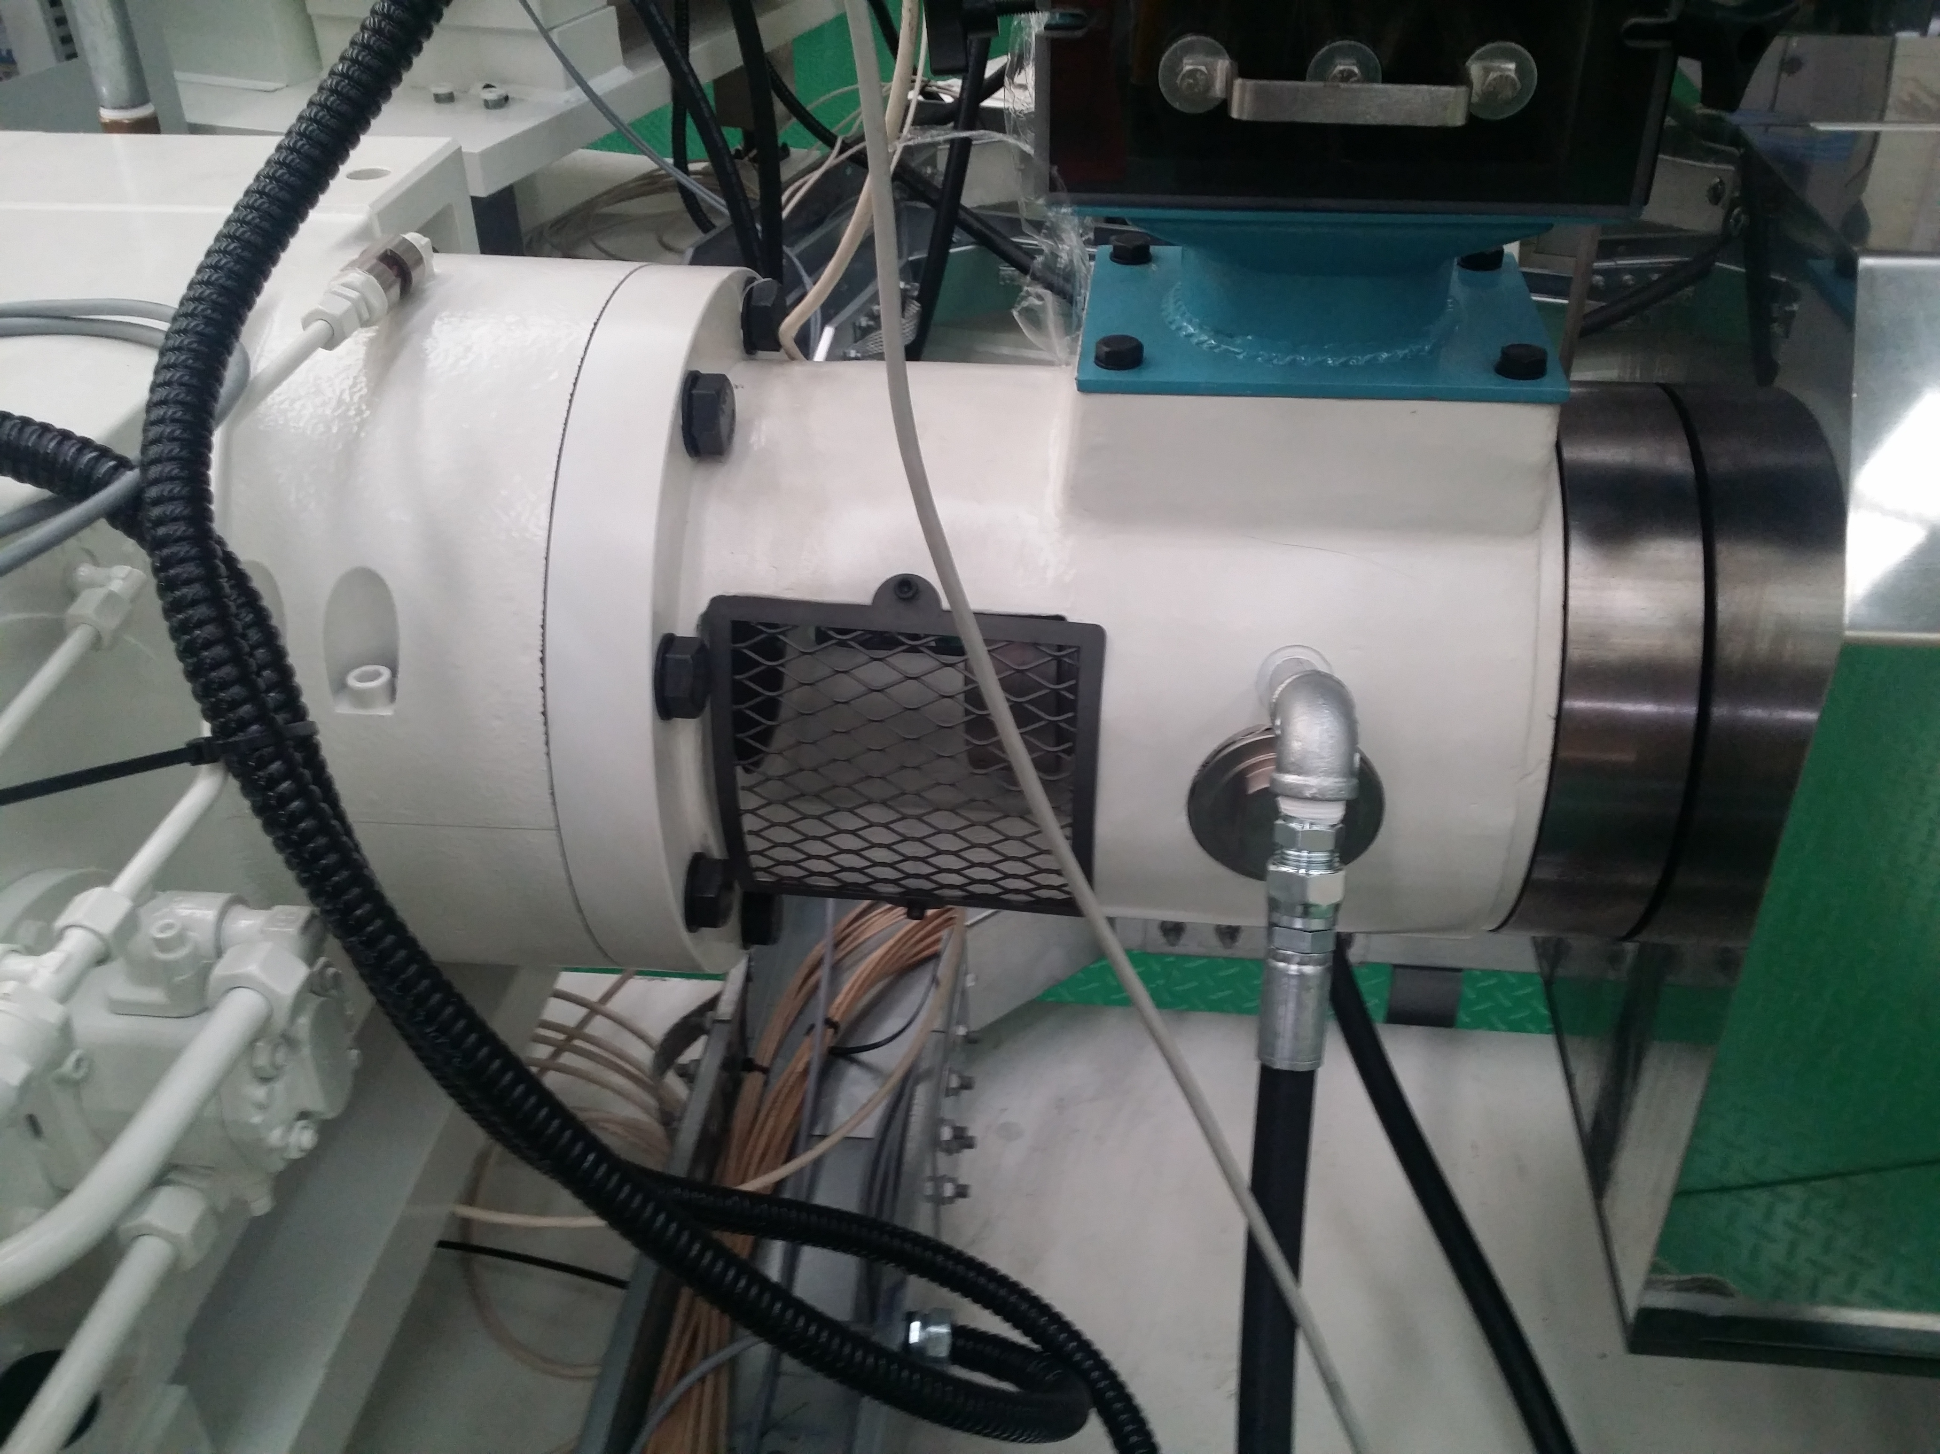
Figure 4A-11. Feed Cylinder
The feed cylinder is a heavy-duty ductile cast iron assembly with an integral water jacket with pre-piped cooling water to prevent resin bridging. It has a rectangular opening for resin supply and a replaceable screw shaft seal. A large air spacer with a safety guard is provided for thermal isolation and access to the feed section bushing without the need for machine disassembly.
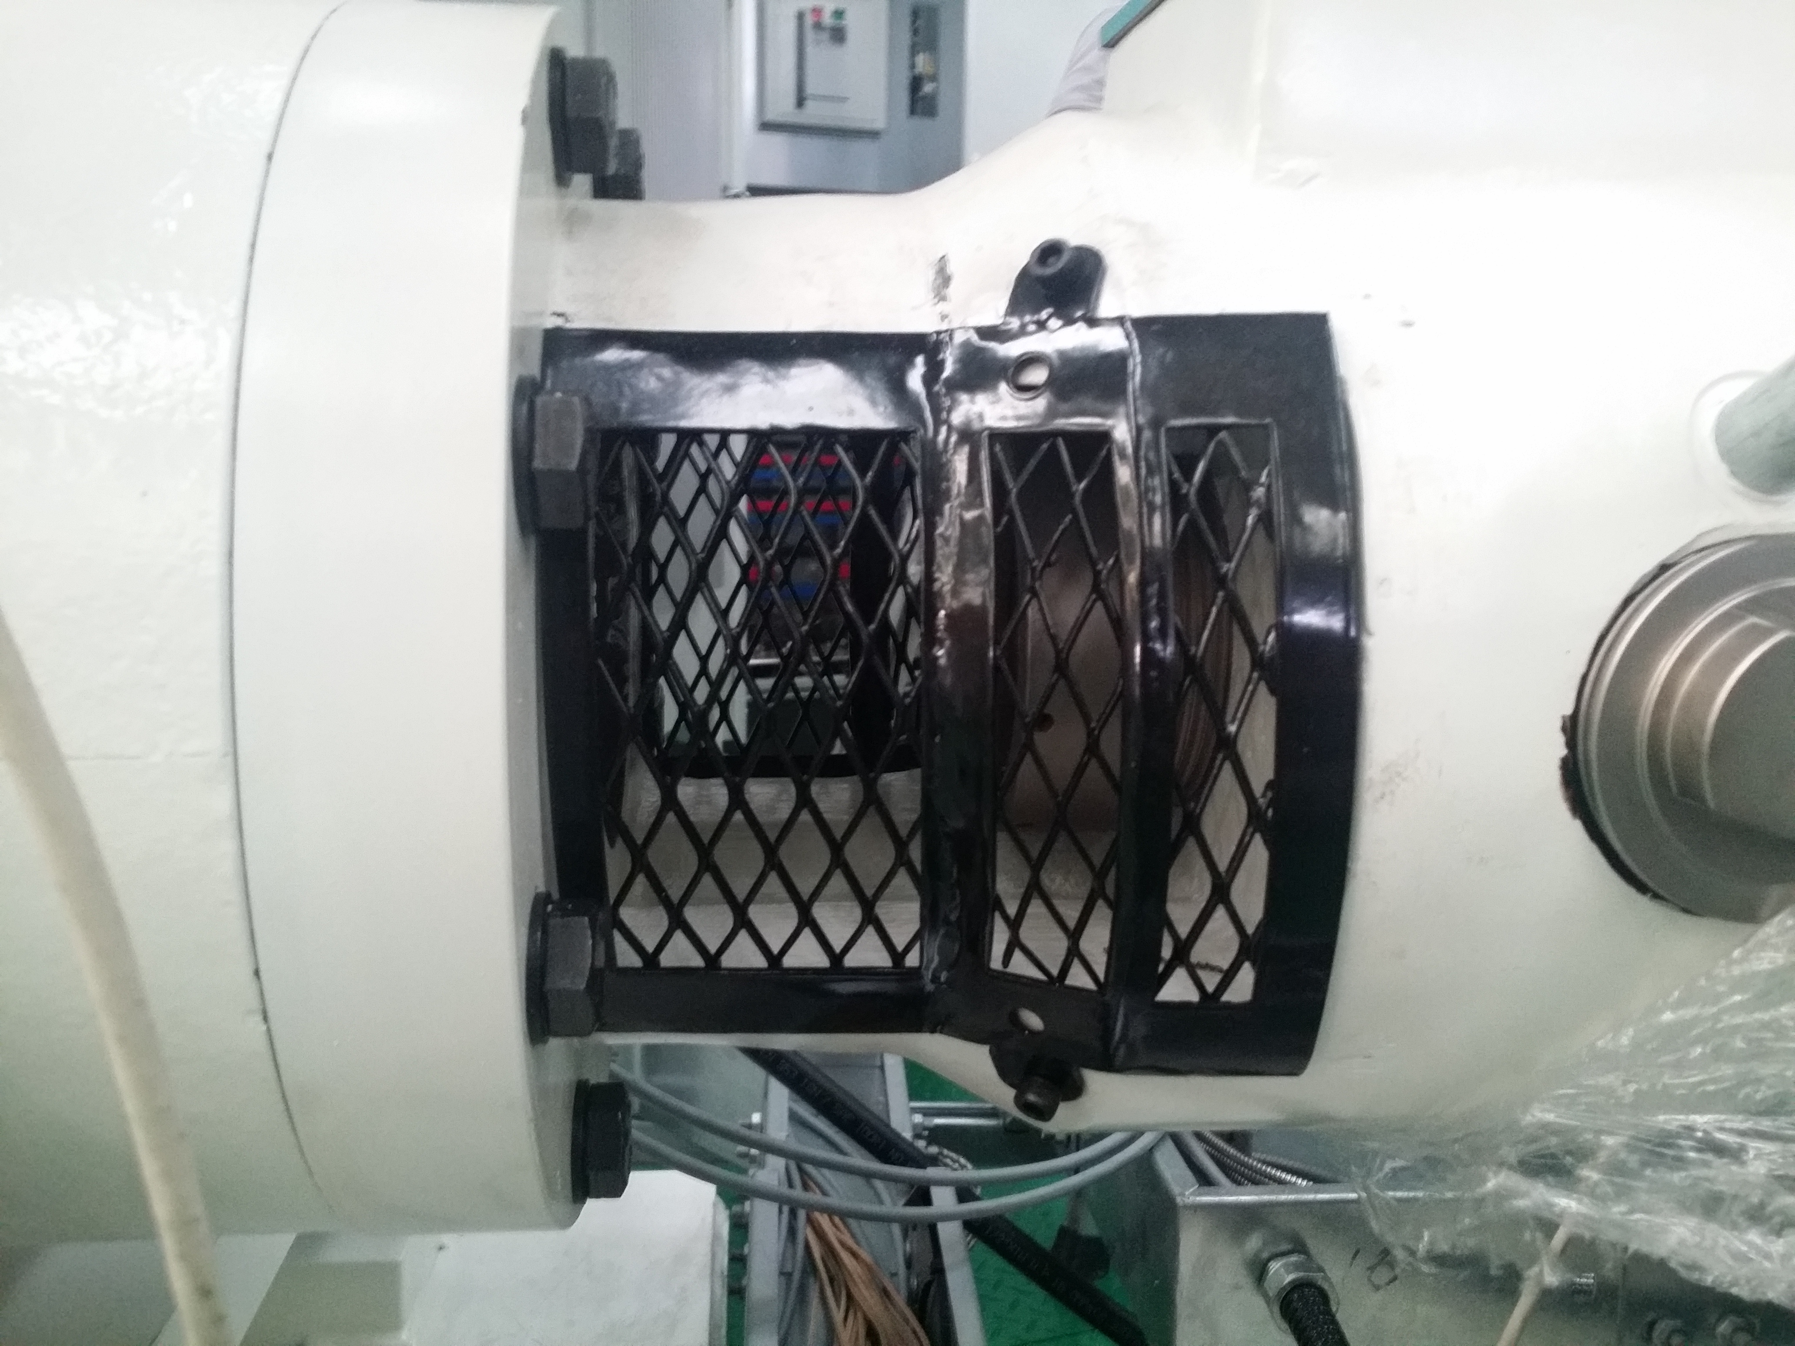
Figure 4A-12. ø90 mm Screw Feed Cylinder

Feed Cylinder Cooling
It is important that the pellets remain relatively stable at this point. Any melting or softening can cause a melt block preventing material from being fed forward while the screw is rotating. Feed cylinder cooling prevents melt blocks.
Bridging of material in the feed cylinder occurs because of the tendency of the material to become sticky when it is heated. To keep the pellets from premature melting, cooling water is supplied to the jacket on a separate feed section. The feed cylinder is ductile casted and jacketed inside to circulate the cooling water from one end to the other end.
The water flow rate is regulated by a manual valve so that the feed cylinder temperature remains very close to ambient temperature and is controllable. The water flow rate should be adjusted so that the feed cylinder temperature remains very close to ambient temperature. This will normally require a flow rate of less than 20 liters per minute.
Requirements for feed cylinder temperature might vary among polymers. When running a variety of materials, determine the best water flow rate for each material and record this data.

Barrels
The barrel is a seamless tube. It has a bimetallic alloy liner with centrifugally cast inside which is finally honed to precise tolerances. The barrels hold the tubes containing the feed screws that compress, meter, and feed pellets received from the feed cylinder to form the extrudate that leaves the Extruder.
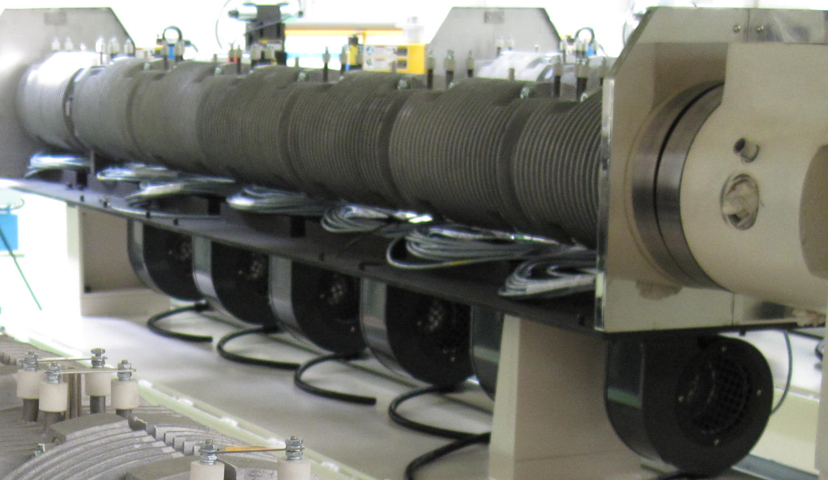
Figure 4A-13. Barrel and Cooling Fans
The barrels are bimetallic inlay X102 with hard-lined-with-alloy steel backing material BM 32 rated at 700 kg/cm². It is precision honed. There are heavy-duty flanges at both ends, with a single-vent liquid injection port (plugged for customer use) located for volatiles extraction and a mechanical vent plug.
The barrels are bimetallic inlay X102 with hard-lined-with-alloy steel backing material BM 32 rated at 700 kg/cm². It is precision honed. There are heavy-duty flanges at both ends.
The barrels have type “J” thermocouples for each zone. The adapter contains a safety rupture disc at discharge rated at 525 kg/cm² with temperature monitoring and alarming.
There are aluminum finned cast-in heaters. There are clamping bolts to maintain intimate thermal contact through both heating and cooling cycles. The cooling blowers are highly efficient, made from sheet metal shrouding to force air between the cooler fins.

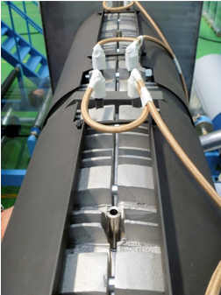
Thermocouple Bayonet
Figure 4A-14. Thermocouple
 |  | Barrel heaters have outside covers. The covers remain on their holding pins when the fixing screws are released and the two halves correctly "open up" by spring force. Be careful when handling the covers because they are not fixed when screws are released.

Barrel Zones
The barrels are divided into zones. The ø115 mm and ø90 mm screws have six barrel zones; ø75 mm and ø65 mm screws have five barrel zones; and the ø50 mm screw has four barrel zones.
Screw size | Number of Zones
115mm | 6 zones
90mm | 6 zones
75mm | 5 zones
65mm | 5 zones
50mm | 4 zones
Table 4A-1. Barrel Zones
Each zone has its own heater that contains incoloy sheathed heating elements and a blower for air cooling a particular zone.
Thin cast aluminum heaters provide efficient cooling. The heater arrangement for each zone consists of two halves of cast aluminum finned heaters. Each pair of heaters encircles the barrel and is held together by clamping bolts to maintain full contact between the heaters and the barrel.
A shroud encloses the heater and is removable to allow access to the heater.
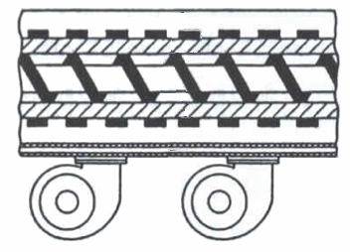
Cooling blowers for two zones
Screw
Barrel heater
Figure 4A-15. Barrel Component Drawing
The barrels are lined with Xaloy with cast aluminum finned heaters with high efficiency cooling blowers with soft start controls. Clamping bolts maintain intimate thermal contact through the heating and cooling cycles with sheet metal shrouding to force air between the cooling fins.

Heating and Cooling
Each heater unit has 10 mm diameter thermocouple holes to control and monitor the zone temperature. Both the heating and cooling cycles for each zone are automatically controlled by the temperature controller.
At very low screw speeds, the heat generation inside the Extruder is not sufficient to maintain the set temperatures, even though all barrel zones need heating. At high screw speeds, the Extruder generates excessive heat and the barrel zones (except the first one two zones) overheat if they are not cooled.
A bolted heater shroud encloses the heater and provides the air path through the heater surface with the cooling blower. The shroud is made of steel and can be removed to access the heaters.

Screws
Each Extruder screw— ø50 mm, two ø65 mm, ø75 mm, ø90 mm, and ø115 mm—is fabricated according to the design of R. Dray Manufacturing.
The screws are the most important component of the Extruder. The Extruder’s performance depends directly on the screw design. As such, the screws on the NAIB Line 5 machine have been designed to optimize its production rate.
The screws perform three basic functions:
- Convey pellets.
- Melt the pellets.
- Meter and pump the pellets into the downstream equipment.
The screws also perform distributive mixing and dispersive mixing.
Here is a depiction of the basic screw design.

Feed Transition Meter Mix Meter

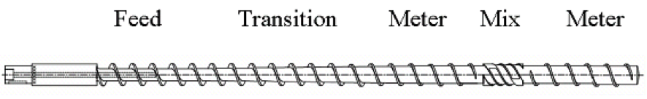
Figure 4A-16. Single-Mixer Screw
The full face of the screw flights is hard surfaced with Colmonoy 56 to improve wear resistance.
Five Extruders (ø115 mm, ø90 mm, ø75 mm, ø65 mm) contains 4140HT screws with hard chrome plated flow channels; the other Extruder (ø50 mm) contains a 17-4PH screw made of hard chrome-plated stainless steel.
All screws have a computational fluid dynamics engineered screw design.

The 32:1 L/D barrier screw is provided with single mixer.
The screw surface is highly polished to minimize sticking and stagnation of the polymer and plated with chrome to provide increased corrosion protection.

Screw Cooling
The Extruder provides cooling to the feed cylinder. Feed screw cooling adjusts the screw root temperature, improves feeding of some resins, and prevents premature melting and melt blocks.
Figure 4A-17. Cooling System to the Feed Cylinder

Manual Screw Pusher
The screw pusher is used to push a screw from its housing for cleaning. It consists of a threaded ring and a threaded push rod to match. It bolts onto the back of the gear reducer. The push rod has a lubricated rotary nose piece so the nose remains stationary while the rod rotates. A long wrench inserted into the square socket on the outer ends is used to rotate the rod.

Piping and Wiring
All cooling water is pre-piped to common inlet and outlet manifolds. A stainless pipe line and brass fittings connect the cooling water supply.
All heaters and thermocouples are pre-wired to terminal strips. Wiring enables remote local Emergency Stop buttons.

Screen Changers
The screen changer allows dirty screen packs to be replaced while the Extruder is stopped. The breaker plate generates head pressure at the end of the barrel.
The surface of a screen changer is very hot. Use caution and wear appropriate clothing as well as heat resistant gloves, a long sleeve shirt, and a face shield.

There are manual screen changers for the ø75 mm, ø65 mm and ø50 mm Extruders. Each has one zone temperature control and a spare breaker plate.
The screen changers include a removable breaker plate, flow passage, upstream seal, band heater with thermocouple well with an adapter and multi-position handle.
Die cut the screen mesh plate with no rims. Selecting the appropriate mesh screen depends on the polymer and is usually used with multiple layers.
There are auto screen changers for the ø115 mm and ø90 mm Extruders.

Melt Pumps
The melt pumps deliver the extrudate through the downspouts. The melt pumps have a pressure transducer at the pump inlet, another pressure transducer downstream, and three melt temperature probes. There are AC drive motors that power each melt pump.
There are melt separators on each Extruder before the melt pumps. The extrudate is divided between the front and back melt pump inlets. The melt pumps maintain the flow rate according to a signal from the resin blender flow rate or the value set at the HMI screen. Screws continue to rotate to maintain a constant pressure (which is set at the HMI).
There are three operation modes for the melt pumps:
Melt Manual RPM. The melt pumps operate at constant rpm which is set at the Screw Control HMI screen
Gravity Auto ON. The melt pumps run to maintain the flow rate according to the signal from the resin blender flow rate when Gravity Auto mode is ON.
Gravity Auto OFF. The melt pumps run to maintain the flow rate according to the line speed and value of extrusion control set at the HMI when Gravity Auto mode is OFF.

Resin Specifications
These are the resin specifications for the Extruder.
Extruder (mm) | Resin Type | Temperature (°C) | Maximum Output Rate (Lbs/hr) | Maximum Output Rate (Lbs/hr)
ø115 mm (A1) | LDPE¹ | 550 | 1,100 | 400
ø90 mm (A2) | LDPE¹ | 550 | 750 | 400
ø75 mm (C) | Nylon | 550 | 350 | 100
ø65 mm (D/E) | LDPE | 550 | 250 | 50
ø50 mm (B) | TIE | 550 | 100 | 40
¹ LDPE is LD/LLDPE/repro blend. Repro blend contains nylon up to 15%.
Extruders A1 and A2 are a blend of LLDPE/LDPE/mLLDPE/repro (core layer, 50% to 75% by weight).
Extruders D and E run a virgin blend of LDPE/LLDPE/mLLDPE (skin layer, 5% to 15% by weight).
Extruder C is barrier layer of Nylon PA6 (average 10% to 15% by weight).
Extruder B is a LLDPE based adhesive resin (average 4% by weight).
Table 4A-2. Resin Specifications

Smoke Hoods
The smoke hoods and accompanying exhaust system remove vapors generated as the hot polymer exits the die and contacts the air.
The smoke hoods are made of stainless steel sheet metal. There is an exhaust on each side of the die connected to flexible and rigid ductwork that in turn connects to the smoke hood. The various elements of a typical exhaust hood system are a deflector, exhaust hood (with individual damper zones), duct work, damper, exhaust fan, slip duct, and roof exit.
SAM supplies the components from the exhaust hood up to the exhaust fan, including the deflector, duct work and supports, dampers, and other connections. The customer must provide the connection from the exhaust fan through the roof exit.
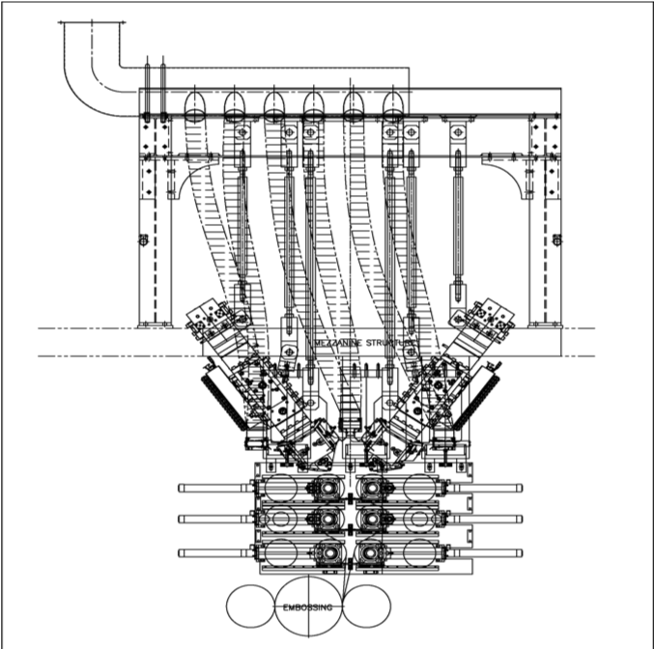
Smoke hoods
Main Smoke hood duct
Figure 4A-18. Smoke Hoods

Instrumentation and Controls

Melt Pressure
A melt pressure transducer is mounted at the head end of the Extruder barrel for sensing the head pressure. It provides an excitation voltage to convert it to the pressure in kg/cm² and provides an output signal of so many millivolts per volt of deviation.
The melt pressure transducer has a range of up to 700 kg/cm² (although this pressure should never be attained).
Only remove the transducer when the machine is cold or the Extruder is empty (not under pressure), otherwise hardened plastic might adhere to the thin diaphragm resulting in a torn diaphragm. Remove the sensor only while the plastic is hot and liquid.
Melt pressure is primarily used to determine if the extrudate is flowing easily. If, for some reason, the plastic is prevented from flowing (such as an insufficiently heated feed tube), the melt pressure increases. In general, a problem in the downstream equipment causes the head pressure to rise 70 kg/cm² above the normal operating pressure. When this happens, stop the Extruder and research the problem.
A pressure transducer is also located downstream of the valve (after the beaker plate) to monitor the downstream pressure.
With a clean, dry cloth, clean molten polymer from the transducer while the tip is still hot. Use solvents or a fluidized bed cleaning system to remove solidified polymer. Never use wire wheels or abrasive cloths to clean the process diaphragm.
Before installing the transducer, first use the special cleaning tool (available from the manufacturer) to clean all polymer from the pressure transducer mounting hole (seat), then apply nickel-based anti-seize compound to the threads on a transducer, as well as to the sealing surface; otherwise, polymer might leak.
Remove the melt pressure transducer and rupture disc whenever the feed screw is removed from the barrel. This prevents damage when using a wire brush to clean the Extruder barrel, and allows you to replenish the anti-seize compound on the threads and sealing surfaces of these units. If the feed screw is not removed for a period of six months, then remove the rupture disc and pressure transducer and reapply the anti-seize compound to prevent seizure.

Melt Temperature Sensor
A melt temperature sensor is mounted downspout for measuring the melt temperature entering the die. For accurate melt temperature measurements, its sensing tip is exposed and insulated from the casing metal. For the fixed immersion thermocouple, the sensing tip ends at the center of the melt flow. The adjustable tip can be adjusted from flush up the maximum range. Typical care for the temperature sensor is very similar to melt pressure transducer.

Temperature Control Sensors
The temperature control sensors monitor zone temperature through either K-type thermocouples or RTDs located in the barrel and the downstream equipment. These sensors are a spring-loaded bayonet type, with a cap for locking to a pin on the sensor adapter.
The adapter is threaded into the barrel. The coil spring around the sensor provides a loading effect, so periodically check the caps to ensure they are tightly holding the sensors securely. The coil spring around the sensor provides a loading effect. If a reasonable pressure is required to push the cap down for locking, then the sensors are seated correctly. Any caps that do not require some pressure should be adjusted by screwing them up the spring.
Check the bottom portion of the adapter for signs of cracks or splits. A loose sensor not making good contact causes erroneous signals to the controller. The adapter threads should receive a light coating of a high temperature lubricant, such as Fel-Pro C5A Improved, before reinstalling. Use sparingly to prevent the lubricant from contaminating the sensor well.
Use a “Q” size drill brazed to a tee handle and an air hose to occasionally scrape clean the bottom of the drilled sensor hole. Remove the sensor, insert the drill, turn it a few times under hand pressure, blow out the hole, and reinstall the sensor.
Controlling the temperature of the extrusion processing equipment is paramount for safe and efficient operation. The processing temperature affects the power requirements of the Extruder drive, the pressure generated, the amount of shear imparted to the polymer by the screw, and the stability of the plastic flow. Properly controlling the temperature reduces the amount of degradation encountered and therefore, the equipment requires less cleaning.
A thermocouple measures temperatures. It is comprised of two wires of dissimilar metals joined at a single junction. The thermocouple uses the principle of “thermoelectric potential” to generate a small voltage when the two metals are brought into intimate contact. The voltage, measured in millivolts, is dependent upon the temperature at the junction. The temperature control device converts the millivolt signal into a temperature.
Low-level signals generated by the thermocouple cause some common problems:
- Noise from high voltage wiring can be readily picked up by a thermocouple wire, giving an erroneous reading.
- Dirty or loose connections can cause low readings.
- An open connection usually gives a very high reading.
- A short between two of the thermocouple wires reads the temperature at the short.
The most common — and most dangerous — error is failing to reinstall a thermocouple following routine maintenance. The thermocouple reads air temperature and causes the heater to remain on at full power.
Careful observation during heat-up is important. Monitor the control system and diagnose false readings to prevent undesirable and the sometimes dangerous consequences of false low readings on temperature control equipment.

Thermocouple Break Protection
All temperature controllers on the Extruder are equipped with thermocouple break protection. In the event of a sensor junction or lead wire break, the controller drives up scale beyond the set point and shuts off the power to its control point. A poorly seated sensor can result in a run-away zone.
A sensor that fails to properly sense the temperature causes overheating and creates a hazardous condition. When checking or recalibrating sensors, be sure they are properly seated and tightened.

Rupture Disc
A rupture disc is a pressure relief device for over-pressure protection. It bursts within a selected pressure and as a result, vents excessive pressure.
The Extruder is equipped with a rupture disc that bursts at 525 kg/cm² maximum. Manufacturing tolerances and exposure to cyclic loading could cause the disc to burst at a lower pressure than the maximum because localized pressure is often unknown and venting is almost always unexpected.
If the disc bursts, stop the Extruder and replace the rupture disc with an identically rated one. Do not even repair or plug a burst rupture disc or run an extrusion process with a self-repaired or plugged unit.
When changing the rupture disc, reduce the Extruder temperature to the lowest temperature possible so the polymer is still semi-soft. Wear protective gear (including heat resistant gloves, face shield, and long sleeve shirt) and use caution to avoid being burned.

When replacing a rupture disc, always follow safe procedures for working near heated components and molten plastic. Never install or operate the Extruders with a self-repaired or plugged rupture disc.

Before restarting the extrusion process, fully inspect the machine paying particular attention to bolted flanged connections. Any signs of leakage should be corrected. Attempt to identify the cause of the failure (usually starting with the polymer too cold) and take corrective actions.
There is a photoelectric sensor just below rupture disc that detects resin flow from the rupture disc to determine if the rupture disc has burst.
Resin Flow
Rupture disc
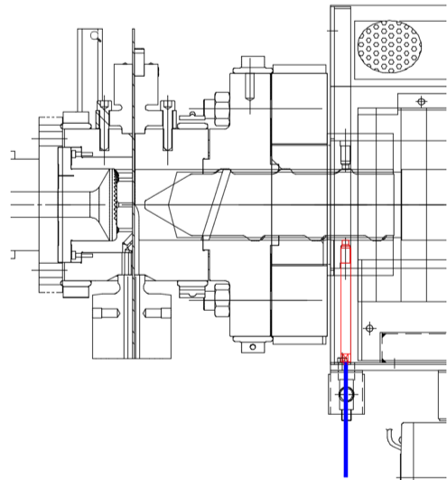
Photoelectric sensor
Figure 4A-19. Rupture Disc Parts

Starting the Extruder
Before starting the Extruders for the first time and after a complete shutdown, perform the following.
- Ensure the free movement of the barrel supports.
- Lubricate or oil all miscellaneous points.
- Check the control circuits.
When all these checks are complete, the Extruders can be started. Heat up the Extruders before starting them.
Heat up the Extruders before starting them. Failure to do so can result in damage to the machine or in personal injury.

Heat the Extruder Barrels
A new Extruder, as well as those that have been completely shut down for cleaning, must be incrementally heated up.
- Turn on the main power source for the Extruder.
- Set the barrel temperature to an initial setpoint of 100°C.
- Switch on each zone as the barrel temperature is set.
- After these initial temperature setpoints have been reached, allow this temperature to “soak” for at least 30 minutes.
- After 30 minutes have passed, increase the temperature setpoint by approximately 30°C.
- Allow this new temperature to “soak” for 20 to 30 minutes.
- Repeat these last two steps four more times until all zones are set at 250°C.
This entire process takes about four hours to complete.

Monitor Progress
Monitor the individual zones as they heat up. If a zone lags behind the others by an appreciable amount, check that zone for problems:
- A bad heater. Replace as necessary.
- A bad contact between the thermocouple and the barrel. If necessary, replace the contact or thermocouple.
Turn all power off before checking the barrels for problems. Do not remove the barrel covers when the power is on. Failing to heed this warning can result in serious personal injury or even death.

- A tight contact between the heater halves. If the halves are loose, retighten the bolts holding them together.
- Check that the current output against the wiring diagram to ensure full current is being drawn.
Proceed after all the zones have reached the setpoint temperature.

Heat the Zones
Set the temperature setpoints on the various zones required to heat the resin. Maintain these temperature for 60 minutes for the larger 90 mm screw.
After the machine has cooled down following the initial heat up, recheck all barrel heater bolts for tightness. Follow the same instructions found in the Maintenance section for installing a replacement heater.

Heat the Dies
Heat the dies in small increments, allowing each increase to “soak”, to minimize any stresses on them. Perform this process the first time the dies are heated, after the Extruder has been shut down for cleaning, and after any new major components have been installed.

As the dies get hotter, the “soak” times get longer.
- Set the initial temperature setpoint to 66°C and let that “soak” for 10 minutes.
- Raise the temperature to 95°C and let “soak” another 10 minutes.
- Raise the temperature to 120°C and then 150°C, “soaking” for 15 minutes after each increment.
- Raise the temperature to 175°C, then 205°C, “soaking” 20 minutes each time.
- Raise the temperature to 230°C, 260°C, then finally to 290°C, “soaking” for 30 minutes each time.
This entire process takes about four hours to complete.

Open the Extruder Head
Always start an Extruder with the head open so that the end of the screw is visible.
Extruded material contains airborne contamination, including particulate matter and fumes. Understand the MSDS material sheet before proceeding. Keep exhaust fans continually operating or severe personal injury can result.

Fill the Feed Cylinders
After the initial heat up, fill or partially fill the feed cylinder with pellets using a plastic (not a metal) container.
Make sure that there is no water or moisture in the barrel or on the pellets as splattering can occur from the open head. Always stay away; wear protective clothing and glasses or a face shield

Keep well clear of the rotating screw.
 |  | Keep your hands away from the rotating screw. Severe personal injury or death can result if you get caught in the rotating screws.

The screen pack installed in the breaker plate contains a number of meshes. Make sure the coarsest mesh is next to the breaker plate, followed in order of mesh size by the remainder of the pack. The total thickness of meshes must not exceed the depth of the groove in the breaker plate. Fully open the valve adapter.

Start the Screws
Start the screw rotating at drool speed: approximately 2–5 revolutions per minute (rpm). Maintain the rotating speed until molten resin flows out through the die or adapter. Allow a certain amount of resin to drool out into a container to ensure that the flow is free from foreign objects. Make sure the downstream equipment is disconnected so that any possible contaminants cannot be pushed into the die.
Before continuing, check the following to ensure that there is no foreign material:
- The instrumentation and controls.
- The zone temperatures and melt pressure.
- The melt quality.

If there are any problems, take corrective measures before proceeding.
For safety reasons, the Extruder is interlocked with the high melt pressure and high melt temperatures that, when occurring, cause an alarm. If this happens, stop the Extruder and consult the drive engineer for the correct settings.

Increase the Rotating Speed
Increase the rotating speed of the screws.
At very slow speeds, the pressure might not reach the process specifications. You might have to adjust the heat settings on the barrel zones to attain the desired melt temperature.
If the temperatures are abnormally high after the screw has reached the desired operating speed, stop the Extruder, discover the root cause, and solve it before proceeding.
Measure the throughput versus the screw speed (rpm) at 25%, 50%, 75%, and 100% of the full speed. Record the data and make a graph (typically linear). This graph forms the basis for determining the screw speed in relation to the line speed, coating thickness, coating width, and any other factors.
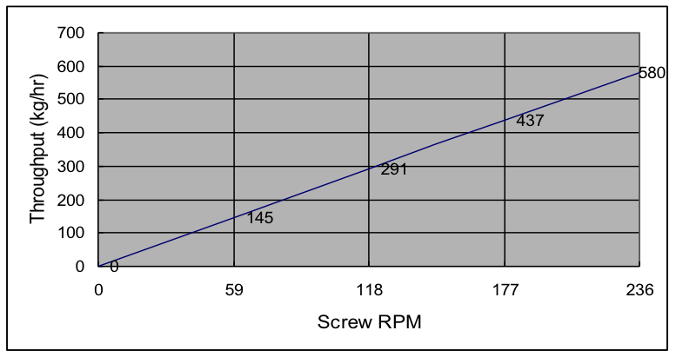
Table 4A-3. Screw RPM Throughput Example Graph

Clean Drool from the Dies
Errant strands of drool can sometimes break off and fall into the tempering rolls causing defects in the coated material. Adjusting the die and the temperature controls usually solve this problem.
If these adjustments do not solve the problem, you must clean the drool off the offending die. To do this, stop the Tempering Roll and back off the six tempering rolls. Always use a long-stem cleaning tool to remove drool.
Do not reach into the machine to remove drool strands with your hands or a short cleaning tool. Because the die is close to the nip, you can easily get caught and pulled into the nip. Failure to heed this warning could easily result in serious injury and even death.

This long-stem cleaning tool must have a solid handle firmly attached to a thin-diameter brass rod, be about a foot long, have a 90° bend about one-inch from its end, and ground to a point.
Using this cleaning tool, either reach in from the face side of the die or from the ends to wipe off the drool strands.

Operating Modes
In general, follow these operating procedures for the Extruders.

About the Machine
- Always preheat the Extruders before beginning.
- Always keep material in the hopper while the die is hot. Never allow them to run dry.
- Do not shut off the Extruders until its temperature falls below 220°C.
Failure to follow these operating procedures could severely damage the machine.

About Drool
- Do not drool overnight or for extended periods.
- When drool mode is set, turn the lip heaters off.
- When the drool time is longer than one hour, lower the die temperatures.
- Drool into an elevated pan to minimize the risk of the curtain blowing out of the pan.
Contacting the molten resin drool can cause severe burns. Avoid it. Immediately soak any body part that contacts the drool in cold water.

About Screw Speed
The screw speed (in rpm) can be set in either auto mode or manual mode.
In auto mode, the machine automatically increases or decreases in direct relation to the line speed. You can also manually increase the screw speed when in auto mode if adjustments are necessary.
In manual mode, you must set the screw speed in relation to the line speed.

Purging the Extruder
Purging the Extruder takes about 10 to 20 minutes when the screws are running at full speed under these conditions:
- Barrel zone temperatures are set at the desired melt temperature.
- All downstream set temperatures match or exceed the melt temperature.
- The new color blend is the same melt index or lower.
Purging takes longer when the screws are running slower.

Shutting Down the Extruder
There are two conditions that can exist when shutting down the Extruders:
- The Extruders will be left loaded.
- The Extruders and the downstream equipment will be completely cleaned.

Shutting Down a Loaded Extruder
When the Extruder will be left loaded, follow these steps.
- Reduce the screw speed to a minimum. In general, do this by shutting down the machine.
- When the screw speed reaches the minimum speed, reduce the setpoints of all heat zones to a temperature at or slightly below the melting point of the resin being extruded. Run the screws until all zones reach this new setpoint.
- Shut off the material feed flow.
- Stop the Extruder screws.
- Turn off all heat control zones and let the machine cool.

Shutting Down and Purging the Extruder
When the resin must be changed to a formulation that is not compatible with the currently-loaded resin, the Extruder and downstream equipment must be shut down and completely cleaned. To do this most effectively, use a purge compound.

Restarting after Shutdown
To start up a machine after shutdown, pre-heat the entire system to a point where the resin is fluid enough to flow.
Insufficiently preheating system can result in damage to the machine and potential harm to the operators. Preheat times vary depending on the product being run. Regardless of the produce, always preheat the machine at least one hour to reach ideal conditions for the extrusion.
Do not start up an Extruder without first allowing the temperature to “soak” to the proper temperature. Failure to follow this warning can seriously damage the machine as well as potentially harm you.

Before starting an Extruder, pre-heat the entire system until the resin is fluid enough to readily flow. While this pre-heat time varies depending on the resin, allow the Extruder to heat up for at least one hour.
Allow the die, the combining adapter, the valve adapter, and the screen changer to reach operating temperature. Slowing increase the temperature of the feed tubes until they are fully heated and stabilize.
Then slowly increase the screw speed. If abnormal temperatures or pressure occur, stop increasing the screw speed until conditions stabilize.
A slow, controlled startup is the preferable path to follow.

